

**"A-1 UNIFORM"**

**E-Project Documentation**

**Student Name : IQRA KHAN**

**Faculty Name : MUHAMMAD SALIH**

**APTECH COMPUTER EDUCATION**

**HYDERABAD-1 PAKISTAN**

**Issue Date : 14-June-2022**

|  |  |  |
| --- | --- | --- |
| **S No** | **Contents** | **Page No** |
| **01** | **Certificate** | **3** |
| **02** | **Acknowledgement** | **4** |
| **03** | **Project Report** | **5** |
| **04** | **Problem Definition** | **6** |
| **05** | **Customer Requirements Specification**  **(CRS)** | **7** |
| **06** | **Architecture Design of the Project** | **9** |
| **07** | **System Requirement** | **9** |
| **08** | **Task Sheet** | **10** |
| **09** | **Project Plan** | **11** |
| **10** | **Checklist of work Progress** | **12** |
| **11** | **Final Check List** | **12** |
| **12** | **Screen Shots** | **16** |
| **13** | **Source Code** | **22** |

**TABLE OF CONTENT**

**CERTIFICATE**

This Is To Certify That

**Iqra Khan**

Has Successfully Designed

**A-1 UNIFORM**

Submitted By:

**IQRA KHAN**

Date of Issue: 14-June-2022

**Authorized Signature:**

**MUHAMMAD SALIH**

**ACKNOWLEDGEMENT**

**First and foremost,**

**I would like to express our deep gratitude and most heartfelt thanks to almighty ALLAH for his blessings, for lightening up our heart with the torch of knowledge and for giving us the ability to complete this project.**

**I would like to thanks Aptech Worldwide and the team of E-Project for their generous support and clarifying the doubts regarding e-project. We would like to acknowledge the way of explanation which the team of e-project gave in e-project to make website and we are equally grateful to our teacher (Sir Salih) for giving us a moral support and guiding us different matters regarding project in all the time about the research and writing of this project.**

**I am greatly indebted to Sir Salih , Faculty Members , Aptech Worldwide, and ACE Hyderabad, Pakistan for encouragement and incessant help.**

**PROJECT REPORT**

**BY:**

**Iqra khan**

**Student1365069**

**Project Title : A-1 Uniform**

**Member Name : Iqra Khan**

**Faculty Name : Muhammad Salih**

**Batch Code : 2201D**

**Start Date : 14- July -2022**

**End Date : 06-June-2022**

**Course : ACCP (DISM)**

**Center Manager : Sir Shoaib Ahmed**

**Center Academic Head : Sir Shoaib Ahmed**

**Center Name : ACE Hyderabad-1, Pakistan**

**Submitted as**

**E Project Documentation**

**PROBLEM DEFINITION**

**A-1 uniforms was founded in 2016 and since then they have been one of the leading Uniform Manufacturers in the country. they supply many schools in country and they give them the best uniforms. They supply affordable school uniforms for girls and boys. When clients come, they cater to client’s vision. As a team of professionals they understand what clients want and deliver the best results.**

**At A-1 uniform designs are innovative and there are always fresh and new ideas for each and every client. The textiles are of excellent quality and they make each uniform according to the size requirements given. The fit is ingenious and they provide with the best. A-1 uniform is a part of a continuous strategic process of creative inputs from experts in the field. They consider each client differently and ensure the satisfaction with the end results. Each client is given the uttermost importance.**

**So taking into consideration the expanding business, the company planned to host the primary information via A-1Uniform.com , an Internet Gateway.**

**Customer Requirement Specification**

**The Web site is to be created based on the following requirements.**

1. **The home page must describe the keywords or highlight of the shop along with all navigation link defined.**
2. **Products should be categorized as**
   1. **Shirts**
   2. **Skirts**
   3. **Frocks**
   4. **P.T. T-shirts**
   5. **P.T. shorts**
   6. **P.T. track pants**
   7. **Belts**
   8. **Ties**
   9. **Logos**
   10. **Socks**
3. **The “Contact Us” page should have the Address of the Company and the mail address which when clicked will invoke the local mail client from where they can send an email. Address of the Company should be displayed using GeoLocation API (e.g. GoogleMaps).**
4. **Contact Us page should also include the address and contact details of various outlets of A-1 uniforms in the city.**
5. **About us page**
6. **Feedback**
7. **Navigation must be smooth.**
8. **Color combination must be uniform throughout the project.**

**Objectives of the project**

**The Objective of this program is to give a sample project to work on real life projects. These applications help you build a larger more robust application.**

**The objective is not to teach you JavaScript/Dreamweaver but to provide you with a real life scenario and help you create basic applications using the tools.**

**You can revise the chapters before you start with the project.**

**This project is meant for students who have completed the module of *HTML5*. These programs should be done in the Lab sessions with assistance of the faculty if required.**

**It is very essential that a student has a clear understanding of the subject. Students should go through the project and solve the assignments as per requirements given.**

**Kindly get back to eProjects Team in case of any doubts regarding the application or its objectives.**

**Architecture & Design of the Project**

**Since the website will have client server architecture it will have two-tier architecture.**

**Hardware/ Software Requirements**

**Hardware**

* **A minimum computer system that will help you access all the tools in the courses is a Pentium 166 or better**
* **64 Megabytes of RAM or better**

**Software**

* **Notepad/HTML editor**
* **Dreamweaver**
* **IE 5.0/ Netscape 6.0**

**TASK SHEET**

|  |  |  |  |  |  |
| --- | --- | --- | --- | --- | --- |
| **Project Ref. No:** | | **Date of Preparation of Activity Plan:** | | | |
| **SR.**  **No** | **Task** | **Actual**  **Start**  **Date:** | **Actual**  **Day:** | **Team**  **Mates**  **Names:** | **Status:** |
| **01** | **Meeting** | **14, June, 2022** | **1** | **Iqra Khan** | **YES** |
| **02** | **Data**  **Collection** | **16, June, 2022** | **5** | **Iqra Khan** | **YES** |
| **03** | **Designing**  **Home**  **Page** | **19, June, 2022** | **7** | **Iqra Khan** | **YES** |
| **04** | **Linking** | **21, June, 2022** | **8** | **Iqra Khan** | **YES** |
| **05** | **Check**  **Links** | **25, June, 2022** | **9** | **Iqra Khan** | **YES** |
| **06** | **Finalizing** | **28, June, 2022** | **10** | **Iqra Khan** | **YES** |
| **07** | **Testing** | **02, July, 2022** | **13** | **Iqra Khan** | **YES** |
| **08** | **Documentation** | **05, July, 2022** | **16** | **Iqra Khan** | **YES** |
| **09** | **Uploading** | **06, July, 2022** | **24** | **Iqra Khan** | **YES** |

**PROJECT PLAN**

* **Website is able to execute quickly.**
* **The color scheme of the site looks attractive.**
* **The collection of data is authentic and taken by the most popular product websites.**
* **There is authentic information of facilities products with their specifications.**
* **Background is different to main page.**
* **The Contact page And Home page is well prepared exactly for the same page as user clicks on the link.**
* **A visitor can also view the individual image of our every gallery.**

**CHECK LIST OF WORK PROGRESS**

|  |  |  |
| --- | --- | --- |
| **SR No** | **Aspect Tested** | **Remarks** |
| **01** | **Data Collection** | **YES** |
| **02** | **Designing Home Page** | **YES** |
| **03** | **Linking The Pages** | **YES** |
| **04** | **Finalization** | **YES** |
| **05** | **Tasting The Site** | **YES** |
| **06** | **Documentation** | **YES** |

**FINAL CHECK LIST**

|  |  |  |  |
| --- | --- | --- | --- |
| **SR No** | **Particulars** | **Yes** | **No** |
| **01** | **Do all pages open?** | **Yes** |  |
| **02** | **Are all hyperlinks working?** | **Yes** |  |
| **03** | **Are the web page contents devoid for**  **spelling mistakes?** |  | **NO** |
| **04** | **Are all the web components working?** | **Yes** |  |
| **05** | **Is site browser compatible?** | **Yes** |  |

**SCREEN SHOTS**

**Home Page 1**

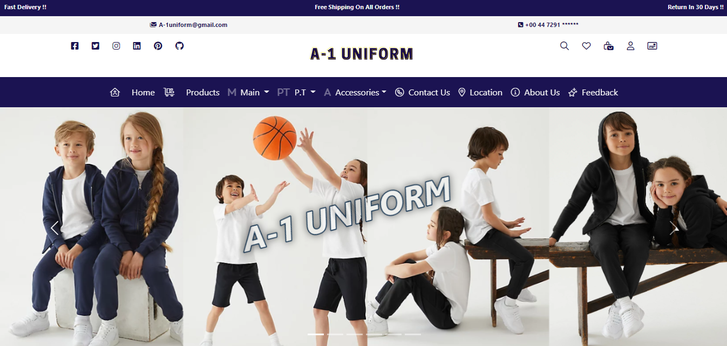

**Home Page 2**

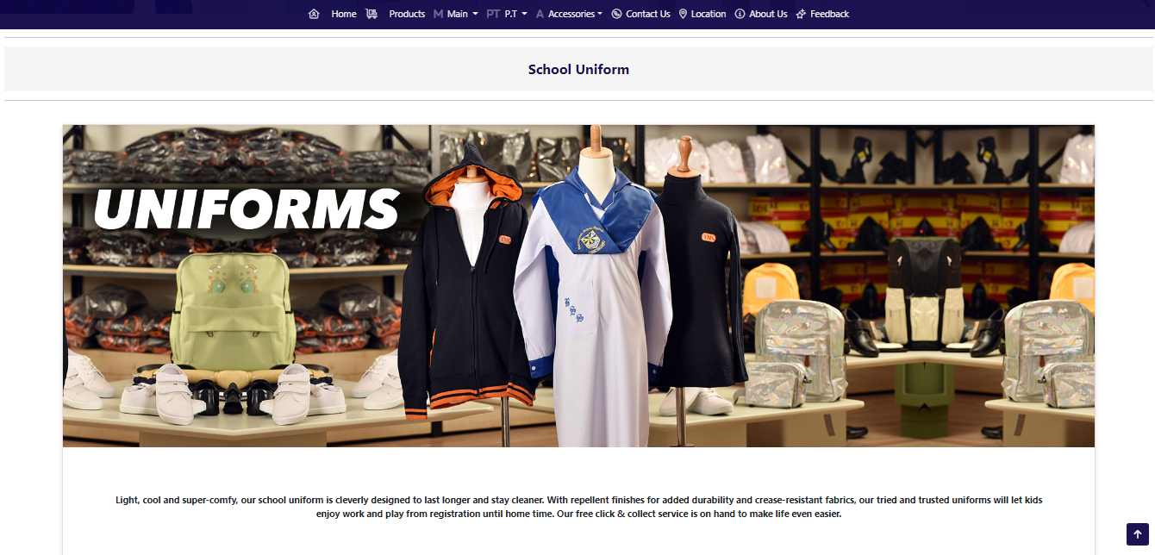

**Home Page 3**

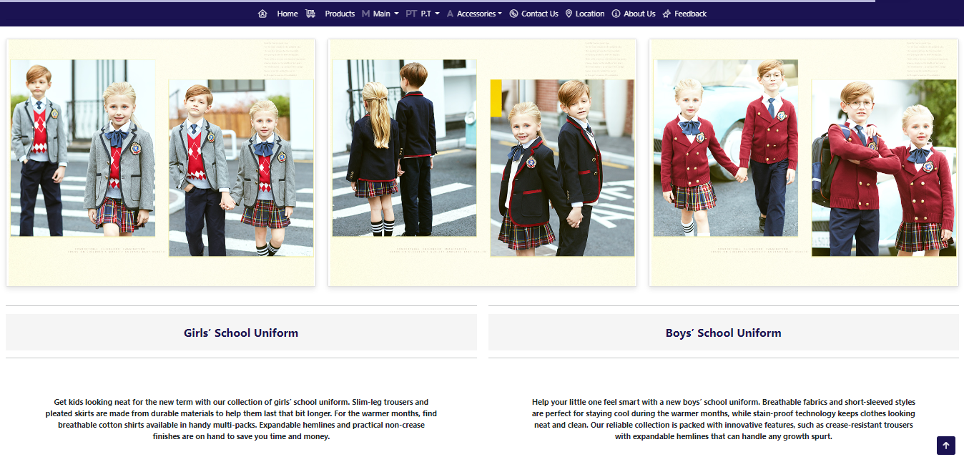

**Contact Us Page 1**

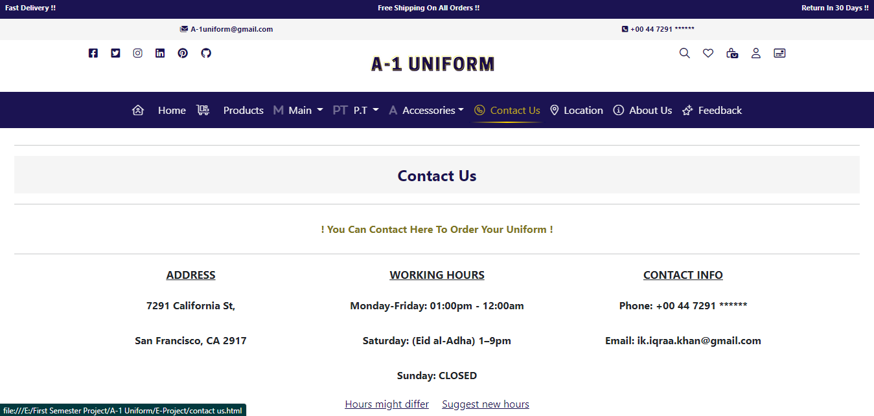

**Contact Us Page 2**

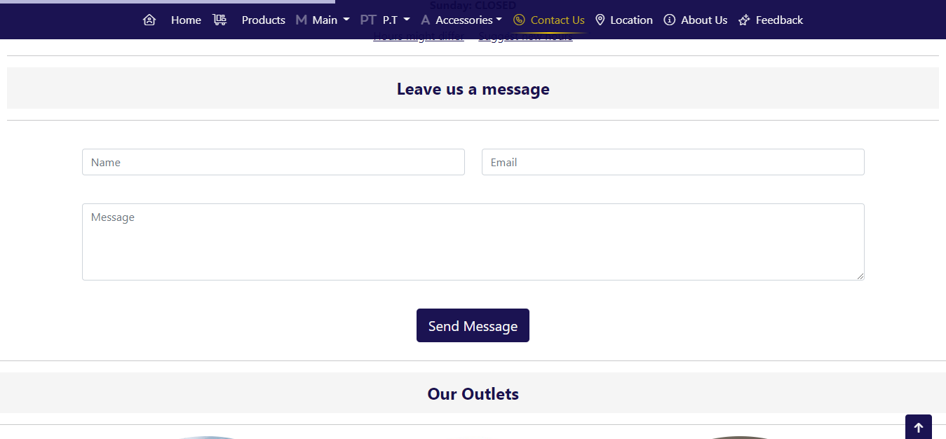

**Contact Us Page 3**

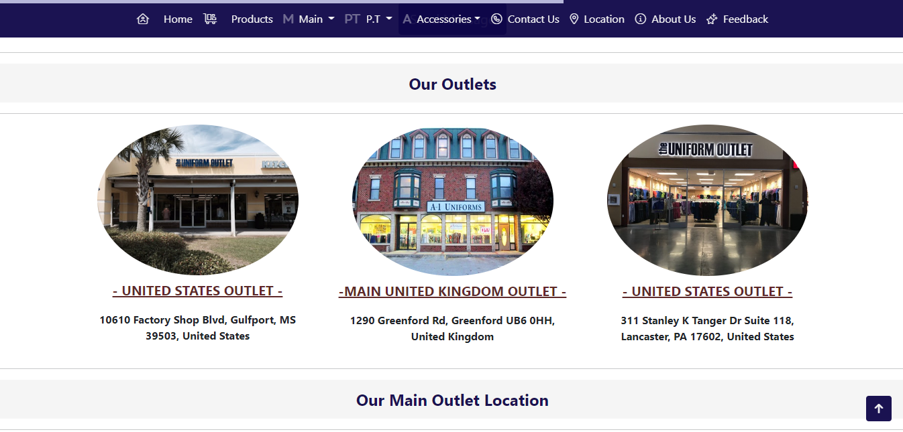

**Location**

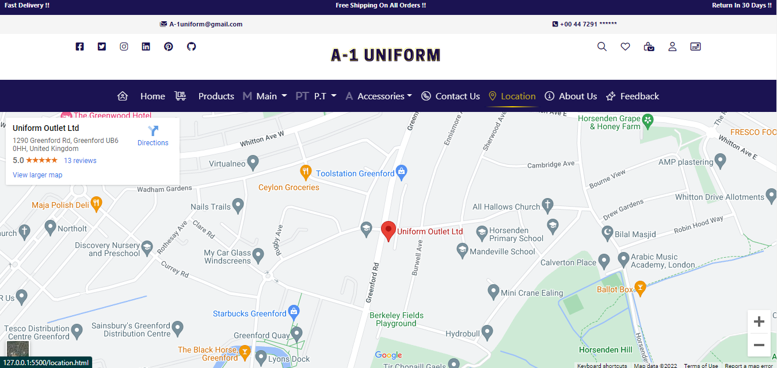

**About Us Page 1**

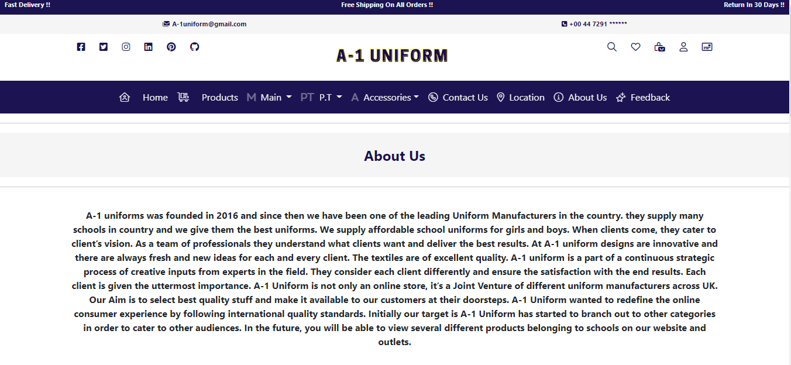

**About Us Page 2**

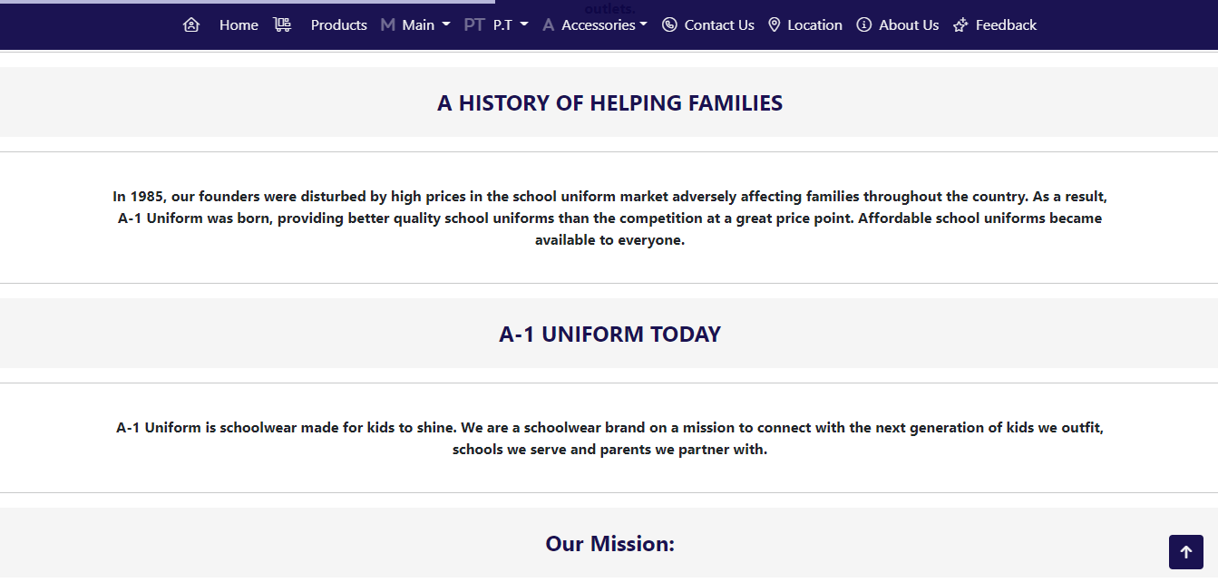

**About Us Page 3**

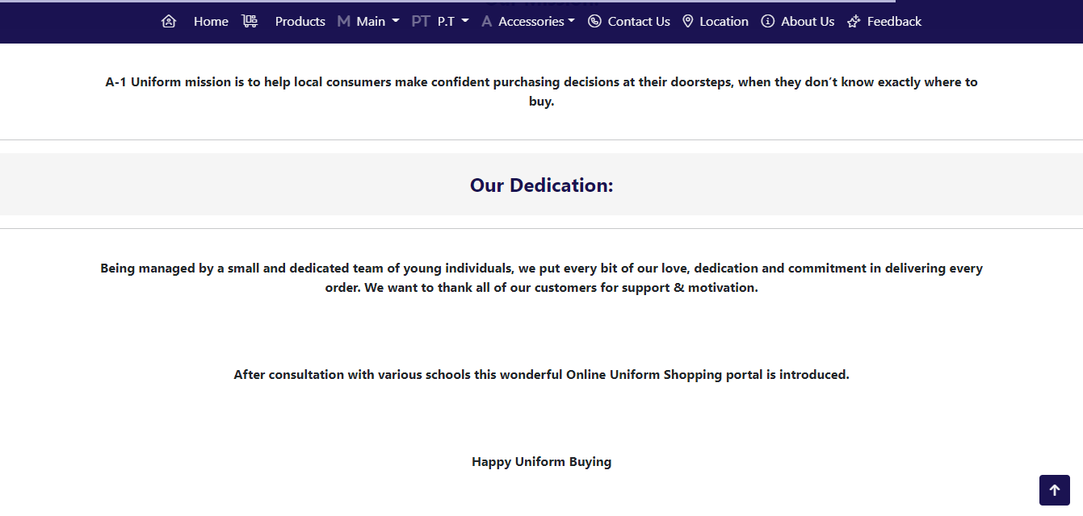

**Feedback Page 1**

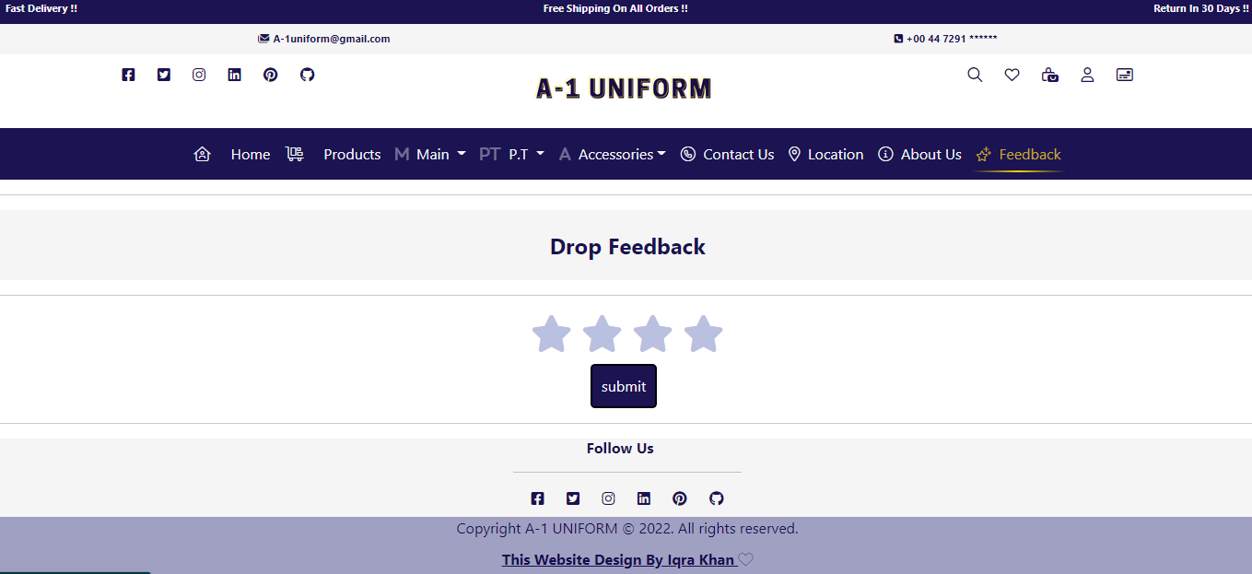

**Feedback Page 2**

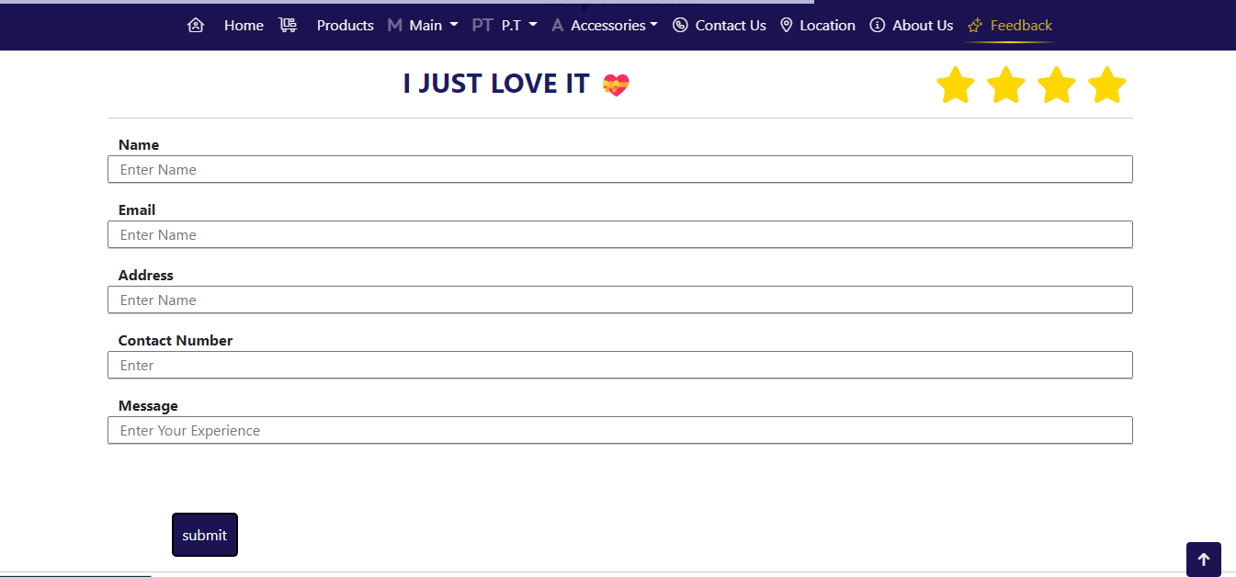

**SOURCE CODE**

**Home Page SC:**

<!DOCTYPE html>

<html lang="en">

<head>

  <meta charset="UTF-8">

  <meta http-equiv="X-UA-Compatible" content="IE=edge">

  <meta name="viewport" content="width=device-width, initial-scale=1.0">

  <link rel="stylesheet" href="https://cdnjs.cloudflare.com/ajax/libs/font-awesome/5.15.3/css/all.min.css" />

  <!-- Bootstrap CDN -->

  <link rel="stylesheet" href="https://cdn.jsdelivr.net/npm/bootstrap@5.2.0-beta1/dist/js/bootstrap.bundle.min.js">

  <link href="https://cdn.jsdelivr.net/npm/bootstrap@5.1.3/dist/css/bootstrap.min.css" rel="stylesheet"

    integrity="sha384-1BmE4kWBq78iYhFldvKuhfTAU6auU8tT94WrHftjDbrCEXSU1oBoqyl2QvZ6jIW3" crossorigin="anonymous">

  <script src="https://cdn.jsdelivr.net/npm/@popperjs/core@2.11.5/dist/umd/popper.min.js"

    integrity="sha384-Xe+8cL9oJa6tN/veChSP7q+mnSPaj5Bcu9mPX5F5xIGE0DVittaqT5lorf0EI7Vk"

    crossorigin="anonymous"></script>

  <script src="https://cdn.jsdelivr.net/npm/bootstrap@5.2.0-beta1/dist/js/bootstrap.min.js"

    integrity="sha384-kjU+l4N0Yf4ZOJErLsIcvOU2qSb74wXpOhqTvwVx3OElZRweTnQ6d31fXEoRD1Jy"

    crossorigin="anonymous"></script>

  <!-- Font Awosome CDN-->

  <link rel="stylesheet" href="https://site-assets.fontawesome.com/releases/v6.1.1/css/all.css">

  <!-- Css -->

  <link rel="stylesheet" href="style.css">

  <!-- Web Title -->

  <title>A-1 Uniforms.com/Index</title>

  <!-- Favicon -->

  <link rel="icon" href="Favicon.png">

</head>

<!-- Header-->

<header>

  <div class="banner1 d-flex justify-content-between p-2">

    <span>Fast Delivery !!</span>

    <span>Free Shipping On All Orders !!</span>

    <span>Return In 30 Days !!</span>

  </div>

  <div class="banner2 d-flex justify-content-around p-2">

    <span> <i class="fa-solid fa-envelopes"></i> A-1uniform@gmail.com</span>

    <span> <i class="fa-solid fa-square-phone"></i> +00 44 7291 ******</span>

  </div>

  <div class="container-fluid banner3 d-flex justify-content-around" style="background-color: white">

    <span class="icons">

      <a href="#"> <i class="fa-brands fa-facebook-square"></i></a>

      <a href="#"> <i class="fa-brands fa-twitter-square"></i></a>

      <a href="#"> <i class="fa-brands fa-instagram"></i></a>

      <a href="#"> <i class="fa-brands fa-linkedin"></i></a>

      <a href="#"> <i class="fa-brands fa-pinterest"></i></a>

      <a href="#"> <i class="fa-brands fa-github"></i></a>

    </span>

    <!-- Brand-->

    <span class="brand"><a href="Index.html" class="logo"><img src="Logo.png"></a></span>

    <span class="icons">

      <a href="#"> <i class="fa-regular fa-search"></i></a>

      <a href="#"><i class="fa-regular fa-heart"></i></a>

      <a href="#"> <i class="fa-regular fa-bags-shopping"></i></a>

      <a href="#"><i class="fa-regular fa-user"></i></a>

      <a href="#"><i class="fa-regular fa-credit-card-front"></i></a>

    </span>

  </div>

</header>

<!--Navigation Bar-->

<nav class="navbar navbar-expand-lg sticky-top">

<div class="container-fluid d-flex justify-content-center">

<button class="navbar-toggler rounded" data-bs-toggle="collapse" data-bs-target="#navbarSupportedContent" aria-controls="navbarSupportedContent" aria-expanded="false" aria-label="Toggle navigation">

    <span><i class="fa fa-bars" id="hamberg-icon"></i></span></button>

    <div class="collapse navbar-collapse justify-content-center" id="navbarSupportedContent">

    <ul class="navbar-nav">

    <li class="active"> <a class="nav-link" href="Index.html"> <i class="fa-light fa-house-user"></i> &nbsp; &nbsp; Home</a></li>

    <li class="nav-item"><a class="nav-link" href="Products.html"><i class="fa-light fa-cart-flatbed-boxes"></i> &nbsp; &nbsp; Products</a></li>

    <li class="nav-item dropdown ">

    <a class="nav-link dropdown-toggle" data-bs-toggle="dropdown"><i class="fa-duotone fa-m"></i>&nbsp;&nbsp;Main </a>

    <ul class="dropdown-menu fade-up mt-1">

    <li><a class="dropdown-item" href="Shirts.html"><i class="fa-light fa-shirt-long-sleeve"></i> &nbsp; &nbsp; Shirts</a></li>

    <li><a class="dropdown-item" href="Skirts.html"><i class="fa-light fa-person-dress"></i> &nbsp; &nbsp; Skirts </a></li>

    <li><a class="dropdown-item" href="Frocks.html"><i class="fa-light fa-person-dress-simple"></i> &nbsp; &nbsp; Frocks</a></li>

    </ul>

    <li class="nav-item dropdown">

    <a class="nav-link dropdown-toggle" data-bs-toggle="dropdown"><i class="fa-duotone fa-p"></i><i class="fa-duotone fa-t"></i>&nbsp;&nbsp;P.T </a>

    <ul class="dropdown-menu fade-up mt-1">

    <li><a class="dropdown-item" href="P.T.T-Shirts.html"><i class="fa-light fa-shirt"></i> &nbsp;&nbsp;P.T T-Shirts </a></li>

    <li><a class="dropdown-item" href="P.T.Shorts.html"><i class="fa-light fa-person-simple"></i>&nbsp;&nbsp; P.T Shorts </a></li>

    <li><a class="dropdown-item" href="P.T Track Pants.html"> <i class="fa-light fa-person"></i>&nbsp;&nbsp;P.T Track Pants </a></li>

    </ul>

    <li class="nav-item dropdown"><a class="nav-link dropdown-toggle" data-bs-toggle="dropdown"><i class="fa-duotone fa-a"></i>&nbsp;&nbsp;Accessories</a>

    <ul class="dropdown-menu fade-up mt-1"><li><a class="dropdown-item" href="Belts.html"><i class="fa-light fa-conveyor-belt-empty"></i>&nbsp;&nbsp; Belts</a></li>

    <li><a class="dropdown-item" href="Ties.html"><i class="fa-light fa-user-tie"></i>&nbsp;&nbsp;Ties</a></li>

    <li><a class="dropdown-item" href="Logos.html"><i class="fa-light fa-badge-check"></i>&nbsp;&nbsp; Logos </a></li>

    <li><a class="dropdown-item" href="Socks.html"><i class="fa-light fa-socks"></i>&nbsp;&nbsp; Socks </a></li>

    </ul>

    </li>

    <li class="nav-item"><a class="nav-link" href="contact us.html"><i class="fa-light fa-circle-phone"></i>&nbsp;&nbsp;Contact Us</a></li>

    <li class="nav-item"><a class="nav-link" href="location.html"><i class="fa-light fa-location-dot"></i>&nbsp;&nbsp;Location</a></li>

    <li class="nav-item"><a class="nav-link" href="about us.html"><i class="fa-light fa-circle-info"></i>&nbsp;&nbsp;About Us</a></li>

    <li class="nav-item"><a class="nav-link" href="feedback.html"><i class="fa-light fa-stars"></i>&nbsp;&nbsp;Feedback</a></li>

    </ul>

    </div>

</div>

  <!-- Progress Bar -->

  <div class="scroll-line"></div>

  <script src="progress bar.js"></script>

  <link rel="stylesheet" href="progress.css">

</nav>

<!-- Carousel-->

<div id="carouselExampleDark" class="carousel carousel-danger slide w-100 col-6 g-0" data-bs-ride="carousel">

  <div class="carousel-indicators">

    <button type="button" data-bs-target="#carouselExampleDark" data-bs-slide-to="0" class="active" aria-current="true"

      aria-label="Slide 1"></button>

    <button type="button" data-bs-target="#carouselExampleDark" data-bs-slide-to="1" aria-label="Slide 2"></button>

    <button type="button" data-bs-target="#carouselExampleDark" data-bs-slide-to="2" aria-label="Slide 3"></button>

    <button type="button" data-bs-target="#carouselExampleDark" data-bs-slide-to="3" aria-label="Slide 4"></button>

    <button type="button" data-bs-target="#carouselExampleDark" data-bs-slide-to="4" aria-label="Slide 5"></button>

    <button type="button" data-bs-target="#carouselExampleDark" data-bs-slide-to="5" aria-label="Slide 6"></button>

  </div>

  <div class="carousel-inner">

    <div class="carousel-item active" data-bs-interval="2000">

      <img src="./Sliders/Slider1.png" class="d-block w-100" alt="...">

      <div class="carousel-caption d-none d-md-block">

      </div>

    </div>

    <div class="carousel-item" data-bs-interval="2000">

      <img src="./Sliders/Slider2.png" class="d-block w-100" alt="...">

      <div class="carousel-caption d-none d-md-block">

      </div>

    </div>

    <div class="carousel-item " data-bs-interval="2000">

      <img src="./Sliders/Slider4.png" class="d-block w-100" alt="...">

      <div class="carousel-caption d-none d-md-block">

      </div>

    </div>

    <div class="carousel-item " data-bs-interval="2000">

      <img src="./Sliders/Slider5.png" class="d-block w-100" alt="...">

      <div class="carousel-caption d-none d-md-block">

      </div>

    </div>

    <div class="carousel-item " data-bs-interval="2000">

      <img src="./Sliders/Slider3.png" class="d-block w-100" alt="...">

      <div class="carousel-caption d-none d-md-block">

      </div>

    </div>

    <div class="carousel-item " data-bs-interval="2000">

      <img src="./Sliders/Slider6.png" class="d-block w-100" alt="...">

      <div class="carousel-caption d-none d-md-block">

      </div>

    </div>

  </div>

  <button class="carousel-control-prev" type="button" data-bs-target="#carouselExampleDark" data-bs-slide="prev">

    <span class="carousel-control-prev-icon" aria-hidden="true"></span>

    <span class="visually-hidden">Previous</span>

  </button>

  <button class="carousel-control-next" type="button" data-bs-target="#carouselExampleDark" data-bs-slide="next">

    <span class="carousel-control-next-icon" aria-hidden="true"></span>

    <span class="visually-hidden">Next</span>

  </button>

</div>

<br>

  <!-- Uniform Description-->

  <div class="container-fluid">

  <hr>

  <h4>School Uniform</h4>

  <hr>

  <br>

  <div class="col-lg-12  d-flex justify-content-center align-items-center">

    <div class="card" style="width:90%;">

      <img src="Description pics/School Uniform.jpg" alt="...">

      <p style="text-align:center;padding:60px;margin: 20px; font-weight: bold;">Light, cool and super-comfy, our school

        uniform is cleverly

        designed to last longer and stay cleaner. With repellent

        finishes for added durability and crease-resistant fabrics, our tried and trusted uniforms will

        let kids enjoy work and play from registration until home time. Our free click & collect service is on hand to

        make

        life

        even easier.</p>

    </div>

  </div>

  <br>

  <hr>

  <br>

  <div class="row">

    <div class="col-lg-4  d-flex justify-content-center align-items-center">

      <div class="card" style="width:100%;">

        <img src="Description pics/1.jpg">

      </div>

    </div>

    <div class="col-lg-4  d-flex justify-content-center align-items-center">

      <div class="card" style="width:100%;">

        <img src="Description pics/2.jpg">

      </div>

    </div>

    <div class="col-lg-4 d-flex justify-content-center align-items-center">

      <div class="card" style="width:100%;">

        <img src="Description pics/3.jpg">

      </div>

    </div>

  </div>

  <br>

  <div class="row">

    <div class="col-sm-6">

      <hr>

      <h4>Girls’ School Uniform</h4>

      <hr>

      <p style="text-align:center;padding:60px;margin: 20px;font-weight: bold;">Get kids looking neat for the new

        term with our collection

        of girls’ school uniform. Slim-leg trousers and pleated

        skirts are made from durable materials to help them last that bit longer. For the warmer months, find

        breathable

        cotton

        shirts available in handy multi-packs. Expandable hemlines and practical non-crease finishes are on hand to

        save

        you

        time and money.

      </p>

    </div>

    <div class="col-sm-6">

      <hr>

      <h4>Boys’ School Uniform</h4>

      <hr>

      <p style="text-align:center;padding:60px;margin: 20px;font-weight: bold;">Help your little one feel smart with

        a new boys’ school

        uniform. Breathable fabrics and short-sleeved styles are perfect

        for staying cool during the warmer months, while stain-proof technology keeps clothes looking neat and

        clean.

        Our

        reliable collection is packed with innovative features, such as crease-resistant trousers with expandable

        hemlines that

        can handle any growth spurt.

      </p>

    </div>

  </div>

</div>

<!--Footer-->

<footer>

  <div class="container-fluid d-flex justify-content-center" style="background-color:whitesmoke">

    <div class="section-title mb-2">

      <h6>Follow Us</h6>

      <hr>

      <span class="icons">

        <a href="#"> <i class="fa-brands fa-facebook-square"></i></a>

        <a href="#"> <i class="fa-brands fa-twitter-square"></i></a>

        <a href="#"> <i class="fa-brands fa-instagram"></i></a>

        <a href="#"> <i class="fa-brands fa-linkedin"></i></a>

        <a href="#"> <i class="fa-brands fa-pinterest"></i></a>

        <a href="#"> <i class="fa-brands fa-github"></i></a>

      </span>

    </div>

  </div>

  <div class="container-fluid d-flex justify-content-center"

    style="background-color: rgb(160, 160, 195);color: #0e0548f1;">

    Copyright A-1 UNIFORM © 2022. All rights reserved.

  </div>

  <div class="container-fluid d-flex justify-content-center"

    style="background-color: rgb(160, 160, 195);font-weight: bold;">

    <a href="#">This Website Design By Iqra Khan <i class="fa-thin fa-heart"></i></a>

  </div>

</footer>

<!-- Scroll Top -->

<button type="button" class="btn btn-floating" id="btn-back-to-top"><i class="fas fa-arrow-up"></i></button>

<!-- Scroll Top Attach Files -->

<script src="scroll top.js"></script>

<link rel="stylesheet" href="scroll top.css">

</body>

</html>

**PRODUCT PAGE SC:**

<!DOCTYPE html>

<html lang="en">

<head>

    <meta charset="UTF-8">

    <meta http-equiv="X-UA-Compatible" content="IE=edge">

    <meta name="viewport" content="width=device-width, initial-scale=1.0">

    <link rel="stylesheet" href="https://cdnjs.cloudflare.com/ajax/libs/font-awesome/5.15.3/css/all.min.css" />

    <!-- Bootstrap CDN -->

    <link rel="stylesheet" href="https://cdn.jsdelivr.net/npm/bootstrap@5.2.0-beta1/dist/js/bootstrap.bundle.min.js">

    <link href="https://cdn.jsdelivr.net/npm/bootstrap@5.1.3/dist/css/bootstrap.min.css" rel="stylesheet"

        integrity="sha384-1BmE4kWBq78iYhFldvKuhfTAU6auU8tT94WrHftjDbrCEXSU1oBoqyl2QvZ6jIW3" crossorigin="anonymous">

    <script src="https://cdn.jsdelivr.net/npm/@popperjs/core@2.11.5/dist/umd/popper.min.js"

        integrity="sha384-Xe+8cL9oJa6tN/veChSP7q+mnSPaj5Bcu9mPX5F5xIGE0DVittaqT5lorf0EI7Vk"

        crossorigin="anonymous"></script>

    <script src="https://cdn.jsdelivr.net/npm/bootstrap@5.2.0-beta1/dist/js/bootstrap.min.js"

        integrity="sha384-kjU+l4N0Yf4ZOJErLsIcvOU2qSb74wXpOhqTvwVx3OElZRweTnQ6d31fXEoRD1Jy"

        crossorigin="anonymous"></script>

    <!-- Font Awosome CDN-->

    <link rel="stylesheet" href="https://site-assets.fontawesome.com/releases/v6.1.1/css/all.css">

    <!-- Css -->

    <link rel="stylesheet" href="style.css">

    <!-- Web Title -->

    <title>A-1 Uniforms.com/products</title>

    <!-- Favicon -->

    <link rel="icon" href="Favicon.png">

    <!-- Attach Files -->

    <link rel="stylesheet" href="Products.css">

    <script src="products.js"></script>

</head>

<!-- Header-->

<header>

<div class="banner1 d-flex justify-content-between p-2">

    <span>Fast Delivery !!</span>

    <span>Free Shipping On All Orders !!</span>

    <span>Return In 30 Days !!</span>

</div>

<div class="banner2 d-flex justify-content-around p-2">

    <span> <i class="fa-solid fa-envelopes"></i> A-1uniform@gmail.com</span>

    <span> <i class="fa-solid fa-square-phone"></i> +00 44 7291 ******</span>

</div>

<div class="container-fluid banner3 d-flex justify-content-around" style="background-color: white">

    <span class="icons">

    <a href="#"> <i class="fa-brands fa-facebook-square"></i></a>

    <a href="#"> <i class="fa-brands fa-twitter-square"></i></a>

    <a href="#"> <i class="fa-brands fa-instagram"></i></a>

    <a href="#"> <i class="fa-brands fa-linkedin"></i></a>

    <a href="#"> <i class="fa-brands fa-pinterest"></i></a>

    <a href="#"> <i class="fa-brands fa-github"></i></a>

    </span>

<!-- Brand-->

    <span class="brand"><a href="Index.html" class="logo"><img src="Logo.png"></a></span>

    <span class="icons">

    <a href="#"> <i class="fa-regular fa-search"></i></a>

    <a href="#"><i class="fa-regular fa-heart"></i></a>

    <a href="#"> <i class="fa-regular fa-bags-shopping"></i></a>

    <a href="#"><i class="fa-regular fa-user"></i></a>

    <a href="#"><i class="fa-regular fa-credit-card-front"></i></a>

    </span>

    </div>

</header>

<!--Navigation Bar-->

<nav class="navbar navbar-expand-lg sticky-top">

<div class="container-fluid d-flex justify-content-center">

<button class="navbar-toggler rounded" data-bs-toggle="collapse" data-bs-target="#navbarSupportedContent" aria-controls="navbarSupportedContent" aria-expanded="false" aria-label="Toggle navigation">

    <span><i class="fa fa-bars" id="hamberg-icon"></i></span></button>

    <div class="collapse navbar-collapse justify-content-center" id="navbarSupportedContent">

    <ul class="navbar-nav">

    <li class="active"> <a class="nav-link" href="Index.html"> <i class="fa-light fa-house-user"></i> &nbsp; &nbsp; Home</a></li>

    <li class="nav-item"><a class="nav-link" href="Products.html"><i class="fa-light fa-cart-flatbed-boxes"></i> &nbsp; &nbsp; Products</a></li>

    <li class="nav-item dropdown ">

    <a class="nav-link dropdown-toggle" data-bs-toggle="dropdown"><i class="fa-duotone fa-m"></i>&nbsp;&nbsp;Main </a>

    <ul class="dropdown-menu fade-up mt-1">

    <li><a class="dropdown-item" href="Shirts.html"><i class="fa-light fa-shirt-long-sleeve"></i> &nbsp; &nbsp; Shirts</a></li>

    <li><a class="dropdown-item" href="Skirts.html"><i class="fa-light fa-person-dress"></i> &nbsp; &nbsp; Skirts </a></li>

    <li><a class="dropdown-item" href="Frocks.html"><i class="fa-light fa-person-dress-simple"></i> &nbsp; &nbsp; Frocks</a></li>

    </ul>

    <li class="nav-item dropdown">

    <a class="nav-link dropdown-toggle" data-bs-toggle="dropdown"><i class="fa-duotone fa-p"></i><i class="fa-duotone fa-t"></i>&nbsp;&nbsp;P.T </a>

    <ul class="dropdown-menu fade-up mt-1">

    <li><a class="dropdown-item" href="P.T.T-Shirts.html"><i class="fa-light fa-shirt"></i> &nbsp;&nbsp;P.T T-Shirts </a></li>

    <li><a class="dropdown-item" href="P.T.Shorts.html"><i class="fa-light fa-person-simple"></i>&nbsp;&nbsp; P.T Shorts </a></li>

    <li><a class="dropdown-item" href="P.T Track Pants.html"> <i class="fa-light fa-person"></i>&nbsp;&nbsp;P.T Track Pants </a></li>

    </ul>

    <li class="nav-item dropdown"><a class="nav-link dropdown-toggle" data-bs-toggle="dropdown"><i class="fa-duotone fa-a"></i>&nbsp;&nbsp;Accessories</a>

    <ul class="dropdown-menu fade-up mt-1"><li><a class="dropdown-item" href="Belts.html"><i class="fa-light fa-conveyor-belt-empty"></i>&nbsp;&nbsp; Belts</a></li>

    <li><a class="dropdown-item" href="Ties.html"><i class="fa-light fa-user-tie"></i>&nbsp;&nbsp;Ties</a></li>

    <li><a class="dropdown-item" href="Logos.html"><i class="fa-light fa-badge-check"></i>&nbsp;&nbsp; Logos </a></li>

    <li><a class="dropdown-item" href="Socks.html"><i class="fa-light fa-socks"></i>&nbsp;&nbsp; Socks </a></li>

    </ul>

    </li>

    <li class="nav-item"><a class="nav-link" href="contact us.html"><i class="fa-light fa-circle-phone"></i>&nbsp;&nbsp;Contact Us</a></li>

    <li class="nav-item"><a class="nav-link" href="location.html"><i class="fa-light fa-location-dot"></i>&nbsp;&nbsp;Location</a></li>

    <li class="nav-item"><a class="nav-link" href="about us.html"><i class="fa-light fa-circle-info"></i>&nbsp;&nbsp;About Us</a></li>

    <li class="nav-item"><a class="nav-link" href="feedback.html"><i class="fa-light fa-stars"></i>&nbsp;&nbsp;Feedback</a></li>

    </ul>

    </div>

</div>

<!-- Progress Bar -->

    <div class="scroll-line"></div>

    <script src="progress bar.js"></script>

    <link rel="stylesheet" href="progress.css">

</nav>

<!-- Products -->

<section id="products">

    <div class="container-fluid">

    <hr>

    <h4 class="main-heading">Our Products</h4>

    <hr>

</div>

<!--Shirts-->

<div class="container-fluid">

    <hr>

    <h5 class="cards-title">Shirts</h5>

    <hr>

    <p>Our school shirts will keep your little one looking neat and tidy all term long. Crease-proof

            fabrics keep them tidy until home time, while smart stain-proof technology cuts your laundry pile down to size.

            Our convenient multipacks make it easy to stock up on new shirts, which are made from breathable cotton so

            youngsters can enjoy all-day comfort

    </p>

<div class="container">

    <div class="row mt-3">

       <div class="col-md-3">

       <div class="card"><img class="cardimg" src="./Products/Mains/Shirts/1.jpg" alt="" srcset="">

        <div class="img-tittle">2pk Boys' Cotton Regular Fit School Shirts (2-18 Yrs)

        <div class="rs">From £12.00</div>

        <button type="button" class="mybtn" onclick="addTocard()">

         <i class="fa fa-shopping-cart"></i> Add to Cart

     </button>

    </div>

</div>

       </div>

       <div class="col-md-3">

       <div class="card"><img class="cardimg" src="./Products/Mains/Shirts/2.jpg" alt="" srcset="">

        <div class="img-tittle">2pk Girls' Cotton Regular Fit School Shirts (2-18 Yrs)

        <div class="rs">From £12.00</div>

        <button type="button" class="mybtn" onclick="addTocard()">

         <i class="fa fa-shopping-cart"></i> Add to Cart

     </button></div></div>

    </div>

    <div class="col-md-3">

    <div class="card"><img class="cardimg" src="./Products/Mains/Shirts/3.jpg" alt="" srcset="">

    <div class="img-tittle">2pk Boys' Blue Non-Iron School Shirts (2-18 Yrs)

    <div class="rs">From £13.00</div>

    <button type="button" class="mybtn" onclick="addTocard()">

    <i class="fa fa-shopping-cart"></i> Add to Cart

     </button>

     </div>

     </div>

       </div>

       <div class="col-md-3">

       <div class="card"><img class="cardimg" src="./Products/Mains/Shirts/4.jpg" alt="" srcset="">

        <div class="img-tittle">2pk Girls' Blue Non-Iron School Shirts (2-18 Yrs)

        <div class="rs">From £13.00</div>

        <button type="button" class="mybtn" onclick="addTocard()">

         <i class="fa fa-shopping-cart"></i> Add to Cart

     </button>

     </div>

     </div>

    </div>

   </div>

   <br>

   <hr>

   <br>

   <div class="row mt-3">

       <div class="col-md-3">

       <div class="card"><img class="cardimg" src="./Products/Mains/Shirts/5.jpg" alt="" srcset="">

        <div class="img-tittle">2pk Boys' White Non-Iron School Shirts (2-18 Yrs)

            <div class="rs">From £14.00</div>

            <button type="button" class="mybtn" onclick="addTocard()">

             <i class="fa fa-shopping-cart"></i> Add to Cart

         </button>

</div>

</div>

       </div>

       <div class="col-md-3">

       <div class="card"><img class="cardimg" src="./Products/Mains/Shirts/6.jpg" alt="" srcset="">

        <div class="img-tittle">2pk Girls' White Non-Iron School Shirts (2-18 Yrs)

            <div class="rs">From £14.00</div>

            <button type="button" class="mybtn" onclick="addTocard()">

             <i class="fa fa-shopping-cart"></i> Add to Cart

         </button>

    </div>

</div>

       </div>

       <div class="col-md-3">

       <div class="card"><img class="cardimg" src="./Products/Mains/Shirts/7.jpg" alt="" srcset="">

        <div class="img-tittle">3pk Boys' Longer Length Iron School Shirts (4-18 Yrs)

        <div class="rs">From £11.00</div>

        <button type="button" class="mybtn" onclick="addTocard()">

         <i class="fa fa-shopping-cart"></i> Add to Cart

     </button>

    </div>

</div>

       </div>

       <div class="col-md-3">

       <div class="card"><img class="cardimg" src="./Products/Mains/Shirts/8.jpg" alt="" srcset="">

        <div class="img-tittle">3pk Girls' Longer Length Iron School Shirts (4-18 Yrs)

        <div class="rs">From £11.00</div>

        <button type="button" class="mybtn" onclick="addTocard()">

         <i class="fa fa-shopping-cart"></i> Add to Cart

     </button>

    </div>

</div>

       </div>

   </div>

<br>

   <hr>

<br>

   <div class="row mt-3">

       <div class="col-md-3">

       <div class="card"><img class="cardimg" src="./Products/Mains/Shirts/9.jpg" alt="" srcset="">

        <div class="img-tittle">2pk Boys' Slim Fit Non-Iron School Shirts (2-18 Yrs)

        <div class="rs">From £13.00</div>

        <button type="button" class="mybtn" onclick="addTocard()">

         <i class="fa fa-shopping-cart"></i> Add to Cart

     </button>

    </div>

</div>

       </div>

       <div class="col-md-3">

       <div class="card"><img class="cardimg" src="./Products/Mains/Shirts/10.jpg" alt="" srcset="">

        <div class="img-tittle">2pk Girls' Slim Fit Non-Iron School Shirts (2-18 Yrs)

        <div class="rs">From £13.00</div>

        <button type="button" class="mybtn" onclick="addTocard()">

         <i class="fa fa-shopping-cart"></i> Add to Cart

     </button>

    </div>

</div>

       </div>

       <div class="col-md-3">

       <div class="card"><img class="cardimg" src="./Products/Mains/Shirts/11.jpg" alt="" srcset="">

        <div class="img-tittle">3pk Boys' Dressing Easy Iron School Shirts (3-18 Yrs)

        <div class="rs">From £11.00</div>

        <button type="button" class="mybtn" onclick="addTocard()">

         <i class="fa fa-shopping-cart"></i> Add to Cart

     </button></div></div>

       </div>

       <div class="col-md-3">

       <div class="card"><img class="cardimg" src="./Products/Mains/Shirts/12.jpg" alt="" srcset="">

        <div class="img-tittle">3pk Girls' Dressing Easy Iron School Shirts (3-18 Yrs)

        <div class="rs">From £11.00</div>

        <button type="button" class="mybtn" onclick="addTocard()">

         <i class="fa fa-shopping-cart"></i> Add to Cart

     </button>

 </div>

</div>

       </div>

   </div>

   <br>

   <hr>

<br>

   <div class="row mt-3">

       <div class="col-md-3">

       <div class="card"><img class="cardimg" src="./Products/Mains/Shirts/13.jpg" alt="" srcset="">

        <div class="img-tittle">2pk Boys' Cotton Slim Fit School Shirts (2-18 Yrs)

        <div class="rs">From £19.00</div>

        <button type="button" class="mybtn" onclick="addTocard()">

         <i class="fa fa-shopping-cart"></i> Add to Cart

     </button>

    </div>

</div>

</div>

       <div class="col-md-3">

       <div class="card"><img class="cardimg" src="./Products/Mains/Shirts/14.jpg" alt="" srcset="">

       <div class="img-tittle">2pk Girls' Cotton Slim Fit School Shirts (2-18 Yrs)

       <div class="rs">From £19.00</div>

       <button type="button" class="mybtn" onclick="addTocard()">

        <i class="fa fa-shopping-cart"></i> Add to Cart

    </button>

       </div>

    </div>

    </div>

       <div class="col-md-3">

       <div class="card"><img class="cardimg" src="./Products/Mains/Shirts/15.jpg" alt="" srcset="">

        <div class="img-tittle">Boys' 2pk Skinny Fit Stretch School Shirts (2-16 Yrs)

       <div class="rs">From £14.00</div>

       <button type="button" class="mybtn" onclick="addTocard()">

        <i class="fa fa-shopping-cart"></i> Add to Cart

    </button>

</div>

</div>

       </div>

       <div class="col-md-3">

       <div class="card"><img class="cardimg" src="./Products/Mains/Shirts/16.jpg" alt="" srcset="">

        <div class="img-tittle">Girls' 2pk Skinny Fit Stretch School Shirts (2-16 Yrs)

        <div class="rs">From £14.00</div>

        <button type="button" class="mybtn" onclick="addTocard()">

         <i class="fa fa-shopping-cart"></i> Add to Cart

     </button>

    </div>

</div>

       </div>

   </div>

   <br>

   <hr>

   <br>

   <div class="row mt-3">

       <div class="col-md-3">

       <div class="card"><img class="cardimg" src="./Products/Mains/Shirts/17.jpg" alt="" srcset="">

        <div class="img-tittle">2pk Boys' 3/4 Sleeve Easy Iron School Shirts (2-16 Yrs)

            <div class="rs">From £11.00</div>

            <button type="button" class="mybtn" onclick="addTocard()">

             <i class="fa fa-shopping-cart"></i> Add to Cart

         </button>

        </div>

</div>

       </div>

       <div class="col-md-3">

       <div class="card"><img class="cardimg" src="./Products/Mains/Shirts/18.jpg" alt="" srcset="">

        <div class="img-tittle">2pk Girls' 3/4 Sleeve Easy Iron School Shirts (2-16 Yrs)

        <div class="rs">From £11.00</div>

        <button type="button" class="mybtn" onclick="addTocard()">

         <i class="fa fa-shopping-cart"></i> Add to Cart

     </button>

    </div>

</div>

       </div>

       <div class="col-md-3">

       <div class="card"><img class="cardimg" src="./Products/Mains/Shirts/19.jpg" alt="" srcset="">

        <div class="img-tittle">3pk Boys' Plus Fit Easy School Shirts (4-18 Yrs)

        <div class="rs">From £7.00</div>

        <button type="button" class="mybtn" onclick="addTocard()">

         <i class="fa fa-shopping-cart"></i> Add to Cart

     </button>

    </div>

</div>

       </div>

       <div class="col-md-3">

       <div class="card"><img class="cardimg" src="./Products/Mains/Shirts/20.jpg" alt="" srcset="">

           <div class="img-tittle">3pk Girls' Plus Fit Easy School Shirts (4-18 Yrs)

       <div class="rs">From £7.00</div>

       <button type="button" class="mybtn" onclick="addTocard()">

        <i class="fa fa-shopping-cart"></i> Add to Cart

    </button>

</div>

</div>

       </div>

   </div>

   <br>

   <hr>

<br>

   <div class="row mt-3">

       <div class="col-sm-6">

       <div class="card"><img class="cardimg" src="./Products/Mains/Shirts/21.jpg" alt="" srcset="">

        <div class="img-tittle">3pk Boys’ Adaptive Easy Iron School Shirts (3-18 Yrs)

        <div class="rs">From £18.00</div>

        <button type="button" class="mybtn" onclick="addTocard()">

         <i class="fa fa-shopping-cart"></i> Add to Cart

     </button>

    </div>

</div>

       </div>

       <div class="col-sm-6">

       <div class="card"><img class="cardimg" src="./Products/Mains/Shirts/22.jpg" alt="" srcset="">

       <div class="img-tittle">3pk Girls’ Adaptive Easy Iron School Shirts (3-18 Yrs)

       <div class="rs">From £18.00</div>

       <button type="button" class="mybtn" onclick="addTocard()">

        <i class="fa fa-shopping-cart"></i> Add to Cart

    </button>

       </div>

</div>

       </div>

    </div>

</div>

<br>

<!--Skirts-->

<hr>

<h5 class="cards-title">Skirts</h5>

<hr>

<p>These girls' school Skirts are worn with shirts underneath for a smart finish. button fastenings mean getting ready in the morning and changing for PE is quick and straightforward. We've designed our girls' school Skirts with permanent pleats and innovative crease-resistant finishes, making them easy to look after.</p>

<div class="container">

<div class="row mt-3">

    <div class="col-md-3">

    <div class="card"><img class="cardimg" src="./Products/Mains/Skirts/1.jpg" alt="" srcset="">

        <div class="img-tittle">2pk Girls' Crease Resistant School Skirts (2-16 Yrs)

    <div class="rs">From £12.00</div>

    <button type="button" class="mybtn" onclick="addTocard()">

        <i class="fa fa-shopping-cart"></i> Add to Cart

    </button>

</div>

</div>

    </div>

    <div class="col-md-3">

    <div class="card"><img class="cardimg" src="./Products/Mains/Skirts/2.jpg" alt="" srcset="">

        <div class="img-tittle">2pk Girls' Regular Fit School Skater Skirts (2-18 Yrs)

    <div class="rs">From £12.00</div>

    <button type="button" class="mybtn" onclick="addTocard()">

        <i class="fa fa-shopping-cart"></i> Add to Cart

    </button>

</div>

</div>

    </div>

    <div class="col-md-3">

    <div class="card"><img class="cardimg" src="./Products/Mains/Skirts/3.jpg" alt="" srcset="">

        <div class="img-tittle">Girls' Embroided School Skirt (2-18 Yrs)

    <div class="rs">From £18.00</div>

    <button type="button" class="mybtn" onclick="addTocard()">

        <i class="fa fa-shopping-cart"></i> Add to Cart

    </button>

</div>

</div>

    </div>

    <div class="col-md-3">

    <div class="card"><img class="cardimg" src="./Products/Mains/Skirts/4.jpg" alt="" srcset="">

        <div class="img-tittle">Girls' Jersey Pleated School Skirt (2-14 Yrs)

    <div class="rs">From £18.00</div>

    <button type="button" class="mybtn" onclick="addTocard()">

        <i class="fa fa-shopping-cart"></i> Add to Cart

    </button>

</div>

</div>

    </div>

</div>

<br>

<hr>

<br>

<div class="row mt-3">

    <div class="col-md-3">

    <div class="card"><img class="cardimg" src="./Products/Mains/Skirts/5.jpg" alt="" srcset="">

        <div class="img-tittle">Girls' Long Pencil School Skirt (9-16 Yrs)

    <div class="rs">From £16.00</div>

    <button type="button" class="mybtn" onclick="addTocard()">

        <i class="fa fa-shopping-cart"></i> Add to Cart

    </button>

</div>

</div>

    </div>

    <div class="col-md-3">

    <div class="card"><img class="cardimg" src="./Products/Mains/Skirts/6.jpg" alt="" srcset="">

        <div class="img-tittle">Girls' Permanent Pleats School Skirt (2-16 Yrs)

    <div class="rs">From £13.00</div>

    <button type="button" class="mybtn" onclick="addTocard()">

        <i class="fa fa-shopping-cart"></i> Add to Cart

    </button>

</div>

</div>

    </div>

    <div class="col-md-3">

    <div class="card"><img class="cardimg" src="./Products/Mains/Skirts/7.jpg" alt="" srcset="">

        <div class="img-tittle">Girls' Pure Cotton Skin Kind™ School Skirt (2-18 Yrs)

    <div class="rs">From £18.00</div>

    <button type="button" class="mybtn" onclick="addTocard()">

        <i class="fa fa-shopping-cart"></i> Add to Cart

    </button>

</div>

</div>

    </div>

    <div class="col-md-3">

    <div class="card"><img class="cardimg" src="./Products/Mains/Skirts/8.jpg" alt="" srcset="">

        <div class="img-tittle">Girls' Short Pencil School Skirt (9-16 Yrs)

    <div class="rs">From £17.00</div>

    <button type="button" class="mybtn" onclick="addTocard()">

        <i class="fa fa-shopping-cart"></i> Add to Cart

    </button>

</div>

</div>

    </div>

</div>

<br>

<hr>

<br>

<div class="row mt-3">

    <div class="col-sm-6">

    <div class="card"><img class="cardimg" src="./Products/Mains/Skirts/9.jpg" alt="" srcset="">

        <div class="img-tittle">Girls' Slim Fit Permanent Pleats School Skirt (2-18 Yrs)

    <div class="rs">From £14.00</div>

    <button type="button" class="mybtn" onclick="addTocard()">

        <i class="fa fa-shopping-cart"></i> Add to Cart

    </button>

</div>

</div>

    </div>

    <div class="col-sm-6">

    <div class="card"><img class="cardimg" src="./Products/Mains/Skirts/10.jpg" alt="" srcset="">

        <div class="img-tittle">School Girls Short Tube School Skirt (9-18 Yrs)

    <div class="rs">From £18.00</div>

    <button type="button" class="mybtn" onclick="addTocard()">

        <i class="fa fa-shopping-cart"></i> Add to Cart

    </button>

</div>

</div>

    </div>

</div>

</div>

<br>

<!-- Frocks -->

<hr>

<h5 class="cards-title">Frocks</h5>

<hr>

<p>These girls' school Frocks are worn with shirts underneath for a smart finish. Front zips and button fastenings mean getting ready in the morning and changing for PE is quick and straightforward. We've designed our girls' school Frocks with permanent pleats and innovative crease-resistant finishes, making them easy to look after</p>

<div class="container">

<div class="row mt-3">

    <div class="col-md-3">

    <div class="card"><img class="cardimg" src="./Products/Mains/Frocks/2pk Girls' Cotton School Frock (2-12 Yrs).jpg" alt="" srcset="">

        <div class="img-tittle">2pk Girls' Cotton School Frock (2-12 Yrs)

    <div class="rs">From £17.00</div>

    <button type="button" class="mybtn" onclick="addTocard()">

        <i class="fa fa-shopping-cart"></i> Add to Cart

    </button></div>

</div>

    </div>

    <div class="col-md-3">

    <div class="card"><img class="cardimg"src="./Products/Mains/Frocks/2pk Girls' Regular Skater School Frock (2-12 Yrs).jpg"alt="" srcset="">

        <div class="img-tittle">2pk Girls' Regular Skater School Frock (2-12 Yrs)

    <div class="rs">From £10.00</div>

    <button type="button" class="mybtn" onclick="addTocard()">

        <i class="fa fa-shopping-cart"></i> Add to Cart

    </button></div>

</div>

    </div>

    <div class="col-md-3">

    <div class="card"><img class="cardimg"src="./Products/Mains/Frocks/Girls' Plus Fit Pleated School Frock (2-12 Yrs).jpg" alt=""srcset="">

        <div class="img-tittle">Girls' Plus Fit Pleated School Frock (2-12 Yrs)

    <div class="rs">From £7.00</div>

    <button type="button" class="mybtn" onclick="addTocard()">

        <i class="fa fa-shopping-cart"></i> Add to Cart

    </button></div>

</div>

    </div>

    <div class="col-md-3">

    <div class="card"><img class="cardimg"src="./Products/Mains/Frocks/Girls' Jersey Frilled School Frock (2-12 Yrs).jpg" alt=""srcset="">

        <div class="img-tittle">Girls' Jersey Frilled School Frock (2-12 Yrs)

    <div class="rs">From £16.00</div>

    <button type="button" class="mybtn" onclick="addTocard()">

        <i class="fa fa-shopping-cart"></i> Add to Cart

    </button></div>

</div>

   </div>

</div>

<br>

<hr>

<br>

<div class="row mt-3">

    <div class="col-md-3">

    <div class="card"><img class="cardimg"src="./Products/Mains/Frocks/Girls' Gingham Pleated School Frock (2-14 Yrs).jpg"alt="" srcset="">

        <div class="img-tittle">Girls' Gingham Pleated School Frock (2-14 Yrs)

    <div class="rs">From £18.00</div>

    <button type="button" class="mybtn" onclick="addTocard()">

        <i class="fa fa-shopping-cart"></i> Add to Cart

    </button>

</div>

</div>

    </div>

    <div class="col-md-3">

    <div class="card"><img class="cardimg"src="./Products/Mains/Frocks/Girls' Gingham Pleated Zip School Frock (2-14 Yrs).jpg"alt="" srcset="">

        <div class="img-tittle">Girls' Gingham Pleated Zip School Frock (2-14 Yrs)

    <div class="rs">From £14.00</div>

    <button type="button" class="mybtn" onclick="addTocard()">

        <i class="fa fa-shopping-cart"></i> Add to Cart

    </button>

</div>

</div>

    </div>

    <div class="col-md-3">

    <div class="card"><img class="cardimg"src="./Products/Mains/Frocks/Girls' Pure Cotton Striped School Frock (2-14 Yrs).jpg"alt="" srcset="">

        <div class="img-tittle">Girls' Pure Cotton Striped School Frock (2-14 Yrs)

    <div class="rs">From £18.00</div>

    <button type="button" class="mybtn" onclick="addTocard()">

        <i class="fa fa-shopping-cart"></i> Add to Cart

    </button>

</div>

</div>

    </div>

    <div class="col-md-3">

    <div class="card"><img class="cardimg" src="./Products/Mains/Frocks/Girls' Gingham Frock (2-14 Yrs).jpg" alt="" srcset="">

        <div class="img-tittle">Girls' Gingham Frock (2-14 Yrs)

    <div class="rs">From £8.00</div>

    <button type="button" class="mybtn" onclick="addTocard()">

        <i class="fa fa-shopping-cart"></i> Add to Cart

    </button>

</div>

</div>

    </div>

</div>

<br>

<hr>

<br>

<div class="row mt-3">

    <div class="col-sm-6">

    <div class="card"><img class="cardimg"src="./Products/Mains/Frocks/Girls Jersey Heart Pocket School Frock (2-12 Yrs).jpg"alt="" srcset="">

        <div class="img-tittle">Girls Jersey Heart Pocket School Frock (2-12 Yrs)

    <div class="rs">From £7.00</div>

    <button type="button" class="mybtn" onclick="addTocard()">

        <i class="fa fa-shopping-cart"></i> Add to Cart

    </button>

</div>

</div>

    </div>

    <div class="col-sm-6">

    <div class="card"><img class="cardimg"src="./Products/Mains/Frocks/Girls' Jersey Bow School Frock (2-12 Yrs).jpg"alt="" srcset="">

        <div class="img-tittle">Girls' Jersey Bow School Frock (2-12 Yrs)

    <div class="rs">From £6.00</div>

    <button type="button" class="mybtn" onclick="addTocard()">

        <i class="fa fa-shopping-cart"></i> Add to Cart

    </button>

</div>

</div>

    </div>

    </div>

</div>

</div>

<br>

   <!--P.T.T-Shirts-->

<hr>

<h5 class="cards-title">P.T. T-shirts</h5>

<hr>

<p>Our school P.T. T-Shirts will keep your little one looking neat and tidy all term long. Crease-proof fabrics

    keep them tidy until home time, while smart stain-proof technology cuts your laundry pile down to size. Our

    convenient multipacks make it easy to stock up on new P.T. T-Shirts, which are made from breathable cotton so

    youngsters can enjoy all-day comfort.</p>

<div class="container">

<div class="row mt-3">

    <div class="col-md-3">

    <div class="card"><img class="cardimg"src="./Products/P.T/P.T.T-Shirts/1.jpg" alt=""srcset="">

        <div class="img-tittle">Red 2 Hex 3 T Shirts (2-18 Yrs)

    <div class="rs">From £18.00</div>

    <button type="button" class="mybtn" onclick="addTocard()">

        <i class="fa fa-shopping-cart"></i> Add to Cart

    </button></div>

</div>

    </div>

    <div class="col-md-3">

    <div class="card"><img class="cardimg" src="./Products/P.T/P.T.T-Shirts/2.jpg"alt="" srcset="">

        <div class="img-tittle">Blue T Shirts (2-18 Yrs)

    <div class="rs">From £18.00</div>

    <button type="button" class="mybtn" onclick="addTocard()">

        <i class="fa fa-shopping-cart"></i> Add to Cart

    </button></div>

</div>

    </div>

    <div class="col-md-3">

    <div class="card"><img class="cardimg"src="./Products/P.T/P.T.T-Shirts/3.jpg" alt=""srcset="">

        <div class="img-tittle">Black T-Shirt (2-16 Yrs)

    <div class="rs">From £18.00</div>

    <button type="button" class="mybtn" onclick="addTocard()">

        <i class="fa fa-shopping-cart"></i> Add to Cart

    </button></div>

</div>

    </div>

    <div class="col-md-3">

    <div class="card"><img class="cardimg"src="./Products/P.T/P.T.T-Shirts/4.jpg" alt=""srcset="">

        <div class="img-tittle">Maroon T-Shirt (2-16 Yrs)

    <div class="rs">From £18.00</div>

    <button type="button" class="mybtn" onclick="addTocard()">

        <i class="fa fa-shopping-cart"></i> Add to Cart

    </button></div>

</div>

   </div>

</div>

<br>

<hr>

<br>

<div class="row mt-3">

    <div class="col-md-3">

    <div class="card"><img class="cardimg"src="./Products/P.T/P.T.T-Shirts/5.jpg" alt=""srcset="">

        <div class="img-tittle">Red Shirts (2-18 Yrs)

    <div class="rs">From £18.00</div>

    <button type="button" class="mybtn" onclick="addTocard()">

        <i class="fa fa-shopping-cart"></i> Add to Cart

    </button></div>

</div>

    </div>

    <div class="col-md-3">

    <div class="card"><img class="cardimg" src="./Products/P.T/P.T.T-Shirts/6.jpg"alt="" srcset="">

        <div class="img-tittle">Sky Blue Shirts (2-18 Yrs)

    <div class="rs">From £18.00</div>

    <button type="button" class="mybtn" onclick="addTocard()">

        <i class="fa fa-shopping-cart"></i> Add to Cart

    </button></div>

</div>

    </div>

    <div class="col-md-3">

    <div class="card"><img class="cardimg"src="./Products/P.T/P.T.T-Shirts/7.jpg" alt=""srcset="">

        <div class="img-tittle">Green T-Shirt (2-16 Yrs)

    <div class="rs">From £18.00</div>

    <button type="button" class="mybtn" onclick="addTocard()">

        <i class="fa fa-shopping-cart"></i> Add to Cart

    </button></div>

</div>

   </div>

    <div class="col-md-3">

    <div class="card"><img class="cardimg"src="./Products/P.T/P.T.T-Shirts/8.jpg" alt=""srcset="">

        <div class="img-tittle">Yellow T-Shirt (2-16 Yrs)

    <div class="rs">From £18.00</div>

    <button type="button" class="mybtn" onclick="addTocard()">

        <i class="fa fa-shopping-cart"></i> Add to Cart

    </button></div>

</div>

    </div>

</div>

<br>

<hr>

<br>

<div class="row mt-3">

    <div class="col-md-3">

    <div class="card"><img class="cardimg"src="./Products/P.T/P.T.T-Shirts/9.jpg" alt=""srcset="">

        <div class="img-tittle">Girls Pure Cotton School Polo T Shirts (2-18 Yrs)

    <div class="rs">From £18.00</div>

    <button type="button" class="mybtn" onclick="addTocard()">

        <i class="fa fa-shopping-cart"></i> Add to Cart

    </button></div>

</div>

    </div>

    <div class="col-md-3">

    <div class="card"><img class="cardimg" src="./Products/P.T/P.T.T-Shirts/10.jpg"alt="" srcset="">

        <div class="img-tittle">Boys Pure Cotton School Polo T Shirts (2-18 Yrs)

    <div class="rs">From £18.00</div>

    <button type="button" class="mybtn" onclick="addTocard()">

        <i class="fa fa-shopping-cart"></i> Add to Cart

    </button></div>

</div>

    </div>

    <div class="col-md-3">

    <div class="card"><img class="cardimg"src="./Products/P.T/P.T.T-Shirts/11.jpg" alt=""srcset="">

        <div class="img-tittle">Girls Stain Resist Polo T-Shirt (2-16 Yrs)

    <div class="rs">From £18.00</div>

    <button type="button" class="mybtn" onclick="addTocard()">

        <i class="fa fa-shopping-cart"></i> Add to Cart

    </button></div>

</div>

    </div>

    <div class="col-md-3">

    <div class="card"><img class="cardimg"src="./Products/P.T/P.T.T-Shirts/12.jpg" alt=""srcset="">

        <div class="img-tittle">Boys Stain Resist Polo T-Shirt (2-16 Yrs)

    <div class="rs">From £18.00</div>

    <button type="button" class="mybtn" onclick="addTocard()">

        <i class="fa fa-shopping-cart"></i> Add to Cart

    </button></div>

</div>

    </div>

</div>

<br>

<hr>

<br>

<div class="row mt-3">

    <div class="col-md-6">

    <div class="card"><img class="cardimg"src="./Products/P.T/P.T.T-Shirts/13.jpg" alt=""srcset="">

        <div class="img-tittle">Boys Pure Cotton School Black Polo T Shirts (2-18 Yrs)

    <div class="rs">From £18.00</div>

    <button type="button" class="mybtn" onclick="addTocard()">

        <i class="fa fa-shopping-cart"></i> Add to Cart

    </button></div>

</div>

    </div>

    <div class="col-md-6">

    <div class="card"><img class="cardimg" src="./Products/P.T/P.T.T-Shirts/14.jpg"alt="" srcset="">

        <div class="img-tittle">Girls Pure Cotton School Black Polo T Shirts (2-18 Yrs)

    <div class="rs">From £18.00</div>

    <button type="button" class="mybtn" onclick="addTocard()">

        <i class="fa fa-shopping-cart"></i> Add to Cart

    </button></div>

</div>

    </div>

</div>

</div>

<br>

<!-- P.T Shorts -->

<hr>

<h5 class="cards-title">P.T Shorts</h5>

<hr>

<p> Our kids' school P.T Shorts are built to look the part and last all term long. They'll keep little learners

    looking smart, and they're durable enough to withstand the playground too. Look out for school P.T Shorts

    with handy features, including stain and crease-resistant technology, while adjustable waists and hemlines are

    perfect for growing kids</p>

<div class="container">

<div class="row mt-3">

    <div class="col-md-3">

    <div class="card"><img class="cardimg" src="./Products/P.T/P.T Shorts/1.jpg" alt="" srcset="">

        <div class="img-tittle">2pk Boys Sport School Shorts (2-16 Yrs)

    <div class="rs">From £18.00</div>

    <button type="button" class="mybtn" onclick="addTocard()">

        <i class="fa fa-shopping-cart"></i> Add to Cart

    </button></div>

</div>

    </div>

    <div class="col-md-3">

    <div class="card"><img class="cardimg" src="./Products/P.T/P.T Shorts/2.jpg" alt="" srcset="">

        <div class="img-tittle">2pk Boys' Cargo School Shorts (2-14 Yrs)

    <div class="rs">From £18.00</div>

    <button type="button" class="mybtn" onclick="addTocard()">

        <i class="fa fa-shopping-cart"></i> Add to Cart

    </button></div>

</div>

    </div>

    <div class="col-md-3">

    <div class="card"><img class="cardimg" src="./Products/P.T/P.T Shorts/3.jpg" alt="" srcset="">

        <div class="img-tittle">2pk Boys' Easy Dressing School Shorts (3-14 Yrs)

        <div class="rs">From £12.00</div>

        <button type="button" class="mybtn" onclick="addTocard()">

            <i class="fa fa-shopping-cart"></i> Add to Cart

        </button></div>

    </div>

    </div>

    <div class="col-md-3">

    <div class="card"><img class="cardimg" src="./Products/P.T/P.T Shorts/4.jpg" alt="" srcset="">

        <div class="img-tittle">2pk Boys' Front Pleat School Shorts (2-14 Yrs)

    <div class="rs">From £12.00</div>

    <button type="button" class="mybtn" onclick="addTocard()">

        <i class="fa fa-shopping-cart"></i> Add to Cart

    </button></div>

</div>

    </div>

</div>

<br>

<hr>

<br>

<div class="row mt-3">

    <div class="col-md-3">

    <div class="card"><img class="cardimg" src="./Products/P.T/P.T Shorts/5.jpg" alt="" srcset="">

        <div class="img-tittle">2pk Boys' Slim Leg Plus Waist School Shorts (4-14 Yrs)

    <div class="rs">From £18.00</div>

    <button type="button" class="mybtn" onclick="addTocard()">

        <i class="fa fa-shopping-cart"></i> Add to Cart

    </button></div>

</div>

    </div>

    <div class="col-md-3">

    <div class="card"><img class="cardimg" src="./Products/P.T/P.T Shorts/6.jpg" alt="" srcset="">

        <div class="img-tittle">2pk Girls Sport School Shorts (2-16 Yrs)

    <div class="rs">From £18.00</div>

    <button type="button" class="mybtn" onclick="addTocard()">

        <i class="fa fa-shopping-cart"></i> Add to Cart

    </button></div>

</div>

    </div>

    <div class="col-md-3">

    <div class="card"><img class="cardimg" src="./Products/P.T/P.T Shorts/7.jpg" alt="" srcset="">

        <div class="img-tittle">Boys Pure Cotton School Shorts (2-16 Yrs)

    <div class="rs">From £17.00</div>

    <button type="button" class="mybtn" onclick="addTocard()">

        <i class="fa fa-shopping-cart"></i> Add to Cart

    </button></div>

</div>

    </div>

    <div class="col-md-3">

    <div class="card"><img class="cardimg" src="./Products/P.T/P.T Shorts/8.jpg" alt="" srcset="">

        <div class="img-tittle">Girls Pure Cotton School Shorts (2-16 Yrs)

    <div class="rs">From £17.00</div>

    <button type="button" class="mybtn" onclick="addTocard()">

        <i class="fa fa-shopping-cart"></i> Add to Cart

    </button></div>

</div>

    </div>

</div>

<br>

<hr>

<br>

<div class="row mt-3">

    <div class="col-md-3">

    <div class="card"><img class="cardimg" src="./Products/P.T/P.T Shorts/9.jpg" alt="" srcset="">

        <div class="img-tittle">Girls Sports School Shorts (2-16 Yrs)

    <div class="rs">From £15.00</div>

    <button type="button" class="mybtn" onclick="addTocard()">

        <i class="fa fa-shopping-cart"></i> Add to Cart

    </button></div>

</div>

    </div>

    <div class="col-md-3">

    <div class="card"><img class="cardimg" src="./Products/P.T/P.T Shorts/10.jpg" alt="" srcset="">

        <div class="img-tittle">Girls' Regular Fit School Shorts (2-16 Yrs)

    <div class="rs">From £15.00</div>

    <button type="button" class="mybtn" onclick="addTocard()">

        <i class="fa fa-shopping-cart"></i> Add to Cart

    </button></div>

</div>

    </div>

    <div class="col-md-3">

    <div class="card"><img class="cardimg" src="./Products/P.T/P.T Shorts/11.jpg" alt="" srcset="">

        <div class="img-tittle">Girls' Turn Up School Shorts (2-16 Yrs)

    <div class="rs">From £13.00</div>

    <button type="button" class="mybtn" onclick="addTocard()">

        <i class="fa fa-shopping-cart"></i> Add to Cart

    </button></div>

</div>

    </div>

    <div class="col-md-3">

    <div class="card"><img class="cardimg" src="./Products/P.T/P.T Shorts/12.jpg" alt="" srcset="">

        <div class="img-tittle">Boys Sports School Shorts (2-16 Yrs)

    <div class="rs">From £13.00</div>

    <button type="button" class="mybtn" onclick="addTocard()">

        <i class="fa fa-shopping-cart"></i> Add to Cart

    </button></div>

</div>

    </div>

</div>

<br>

<hr>

<br>

<div class="row mt-3">

    <div class="col-sm-6">

    <div class="card"><img class="cardimg" src="./Products/P.T/P.T Shorts/13.jpg" alt="" srcset="">

        <div class="img-tittle">School 2pk Boys' Regular Leg Shorts (2-14 Yrs)

    <div class="rs">From £17.00</div>

    <button type="button" class="mybtn" onclick="addTocard()">

        <i class="fa fa-shopping-cart"></i> Add to Cart

    </button></div>

</div>

    </div>

    <div class="col-sm-6">

    <div class="card"><img class="cardimg" src="./Products/P.T/P.T Shorts/14.jpg" alt="" srcset="">

        <div class="img-tittle">School 2pk Girls' Slim Leg Shorts (2-16 Yrs)

    <div class="rs">From £17.00</div>

    <button type="button" class="mybtn" onclick="addTocard()">

        <i class="fa fa-shopping-cart"></i> Add to Cart

    </button></div>

</div>

    </div>

</div>

</div>

<br>

<!-- P.T Track Pants -->

<hr>

<h5 class="cards-title">P.T Track Pants</h5>

<hr>

<p>Our kids' school P.T Track Pants are built to look the part and last all term long. They'll keep little learners

    looking smart, and they're durable enough to withstand the playground too. Look out for school P.T Track Pants

    with handy features, including stain and crease-resistant technology, while adjustable waists and hemlines are

    perfect for growing kids</p><div class="container">

<div class="row mt-3">

    <div class="col-md-3">

    <div class="card"><img class="cardimg" src="./Products/P.T/P.T Track Pants/Boys Cotton Pants(6-16 Yrs).jpg" alt="" srcset="">

        <div class="img-tittle">Boys fitted Cotton Pants(6-16 Yrs)

    <div class="rs">From £17.00 </div>

    <button type="button" class="mybtn" onclick="addTocard()">

        <i class="fa fa-shopping-cart"></i> Add to Cart

    </button></div>

</div>

    </div>

    <div class="col-md-3">

    <div class="card"><img class="cardimg" src="./Products/P.T/P.T Track Pants/Girls Cotton Pants (6-16 Yrs).jpg" alt="" srcset="">

        <div class="img-tittle">Girls fitted Cotton Pants (6-16 Yrs)

        <div class="rs">From £17.00 </div>

        <button type="button" class="mybtn" onclick="addTocard()">

            <i class="fa fa-shopping-cart"></i> Add to Cart

        </button></div>

    </div>

    </div>

    <div class="col-md-3">

    <div class="card"><img class="cardimg" src="./Products/P.T/P.T Track Pants/Boys Cotton Rich Pants  (6-16 Yrs).jpg" alt="" srcset="">

        <div class="img-tittle">Boys Cotton Rich Pants  (6-16 Yrs)

    <div class="rs">From £15.00 </div>

    <button type="button" class="mybtn" onclick="addTocard()">

        <i class="fa fa-shopping-cart"></i> Add to Cart

    </button></div>

</div>

    </div>

    <div class="col-md-3">

    <div class="card"><img class="cardimg" src="./Products/P.T/P.T Track Pants/Girls Cotton Rich Pants  (6-16 Yrs).jpg" alt="" srcset="">

        <div class="img-tittle">Girls Cotton Rich Pants  (6-16 Yrs)

    <div class="rs">From £15.00 </div>

    <button type="button" class="mybtn" onclick="addTocard()">

        <i class="fa fa-shopping-cart"></i> Add to Cart

    </button></div>

</div>

    </div>

</div>

<br>

<hr>

<br>

<div class="row mt-3">

    <div class="col-md-3">

    <div class="card"><img class="cardimg" src="./Products/P.T/P.T Track Pants/Boys Hooded School Pants (2-16 Yrs).jpg" alt="" srcset="">

        <div class="img-tittle">Boys Hooded School Pants (2-16 Yrs)

    <div class="rs">From £16.00 </div>

    <button type="button" class="mybtn" onclick="addTocard()">

        <i class="fa fa-shopping-cart"></i> Add to Cart

    </button>

</div>

</div>

    </div>

    <div class="col-md-3">

    <div class="card"><img class="cardimg" src="./Products/P.T/P.T Track Pants/Girls Hooded School Pants (2-16 Yrs).jpg" alt="" srcset="">

        <div class="img-tittle">Girls Hooded School Pants (2-16 Yrs)

    <div class="rs">From  £16.00 </div>

    <button type="button" class="mybtn" onclick="addTocard()">

        <i class="fa fa-shopping-cart"></i> Add to Cart

    </button></div>

</div>

    </div>

    <div class="col-md-3">

    <div class="card"><img class="cardimg" src="./Products/P.T/P.T Track Pants/Boys School Pants (2-16 Yrs).jpg" alt="" srcset="">

        <div class="img-tittle">Boys Adaptive School Pants (2-16 Yrs)

    <div class="rs">From  £19.00 </div>

    <button type="button" class="mybtn" onclick="addTocard()">

        <i class="fa fa-shopping-cart"></i> Add to Cart

    </button></div>

</div>

    </div>

    <div class="col-md-3">

    <div class="card"><img class="cardimg" src="./Products/P.T/P.T Track Pants/Girls School Pants (2-16 Yrs).jpg" alt="" srcset="">

        <div class="img-tittle">Girls Adaptive School Pants (2-16 Yrs)

    <div class="rs">From  £19.00 </div>

    <button type="button" class="mybtn" onclick="addTocard()">

        <i class="fa fa-shopping-cart"></i> Add to Cart

    </button></div>

</div>

    </div>

</div>

<br>

<hr>

<br>

<div class="row mt-3">

    <div class="col-sm-6">

    <div class="card"><img class="cardimg" src="./Products/P.T/P.T Track Pants/2pk Boys Regular Fit School Pants (2-16 Yrs).jpg" alt="" srcset="">

        <div class="img-tittle">2pk Boys Regular Fit School Pants (2-16 Yrs)

        <div class="rs">From £20.40</div>

    <button type="button" class="mybtn" onclick="addTocard()">

            <i class="fa fa-shopping-cart"></i> Add to Cart

        </button>

    </div>

</div>

    </div>

    <div class="col-sm-6">

    <div class="card"><img class="cardimg" src="./Products/P.T/P.T Track Pants/2pk Girls Regular Fit School Pants (2-16 Yrs).jpg" alt="" srcset="">

        <div class="img-tittle">2pk Girls Regular Fit School Pants (2-16 Yrs)

    <div class="rs">From £20.40</div>

    <button type="button" class="mybtn" onclick="addTocard()">

        <i class="fa fa-shopping-cart"></i> Add to Cart

    </button></div>

</div>

    </div>

</div>

</div>

<br>

 <!-- Belts -->

<hr>

<h5 class="cards-title">Belts</h5>

<hr>

<div class="container">

<div class="row mt-3">

    <div class="col-md-3">

    <div class="card"><img class="cardimg" src="./Products/Accessories/Belts/British Luxury Leather Belt.jpg" alt="" srcset="">

        <div class="img-tittle">British Luxury Leather Belt

    <div class="rs">From £8.00</div>

    <button type="button" class="mybtn" onclick="addTocard()">

        <i class="fa fa-shopping-cart"></i> Add to Cart

    </button></div>

</div>

    </div>

    <div class="col-md-3">

    <div class="card"><img class="cardimg" src="./Products/Accessories/Belts/British Luxury Suede Stitch Detail Belt.jpg" alt="" srcset="">

        <div class="img-tittle">Luxury Suede Stitch Detail Belt

        <div class="rs">From £8.00</div>

        <button type="button" class="mybtn" onclick="addTocard()">

            <i class="fa fa-shopping-cart"></i> Add to Cart

        </button></div>

    </div>

    </div>

    <div class="col-md-3">

    <div class="card"><img class="cardimg" src="./Products/Accessories/Belts/Italian Leather Smart Belt.jpg" alt="" srcset="">

        <div class="img-tittle">Italian Leather Smart Belt

    <div class="rs">From £6.00</div>

    <button type="button" class="mybtn" onclick="addTocard()">

        <i class="fa fa-shopping-cart"></i> Add to Cart

    </button></div>

</div>

    </div>

    <div class="col-md-3">

    <div class="card"><img class="cardimg" src="./Products/Accessories/Belts/Suede Belt.jpg" alt="" srcset="">

        <div class="img-tittle">Suede Belt

    <div class="rs">From £8.00</div>

    <button type="button" class="mybtn" onclick="addTocard()">

        <i class="fa fa-shopping-cart"></i> Add to Cart

    </button></div>

</div>

    </div>

</div>

<br>

<hr>

<br>

<div class="row mt-3">

    <div class="col-md-3">

    <div class="card"><img class="cardimg" src="./Products/Accessories/Belts/Leather Buckle Belt.jpg" alt="" srcset="">

        <div class="img-tittle">Leather Buckle Belt

    <div class="rs">From £6.00</div>    <button type="button" class="mybtn" onclick="addTocard()">

        <i class="fa fa-shopping-cart"></i> Add to Cart

    </button></div>

</div>

    </div>

    <div class="col-md-3">

    <div class="card"><img class="cardimg" src="./Products/Accessories/Belts/Leather Reversible Belt.jpg"alt="" srcset="">

        <div class="img-tittle">Leather Reversible Belt

        <div class="rs">From £6.00</div>

        <button type="button" class="mybtn" onclick="addTocard()">

            <i class="fa fa-shopping-cart"></i> Add to Cart

        </button></div>

    </div>

    </div>

    <div class="col-md-3">

    <div class="card"><img class="cardimg" src="./Products/Accessories/Belts/Leather Smart Belt.jpg" alt="" srcset="">

        <div class="img-tittle">Leather Smart Belt

    <div class="rs">From £6.00</div>

    <button type="button" class="mybtn" onclick="addTocard()">

        <i class="fa fa-shopping-cart"></i> Add to Cart

    </button></div>

</div>

    </div>

    <div class="col-md-3">

    <div class="card"><img class="cardimg" src="./Products/Accessories/Belts/Leather Stretch Belt.jpg" alt="" srcset="">

        <div class="img-tittle">Leather Stretch Belt

        <div class="rs">From £6.00</div>

        <button type="button" class="mybtn" onclick="addTocard()">

            <i class="fa fa-shopping-cart"></i> Add to Cart

        </button></div>

    </div>

    </div>

</div>

<br>

<hr>

<br>

<div class="row mt-3">

    <div class="col-md-3">

    <div class="card"><img class="cardimg" src="./Products/Accessories/Belts/Textured Leather Slim Belt.jpg" alt="" srcset="">

        <div class="img-tittle">Textured Leather Slim Belt

    <div class="rs">From £7.00</div>

    <button type="button" class="mybtn" onclick="addTocard()">

        <i class="fa fa-shopping-cart"></i> Add to Cart

    </button></div>

</div>

    </div>

    <div class="col-md-3">

    <div class="card"><img class="cardimg" src="./Products/Accessories/Belts/Premium Leather Formal Belt.jpg" alt="" srcset="">

        <div class="img-tittle">Premium Leather Formal Belt

    <div class="rs">From £4.00</div>

    <button type="button" class="mybtn" onclick="addTocard()">

        <i class="fa fa-shopping-cart"></i> Add to Cart

    </button></div>

</div>

    </div>

    <div class="col-md-3">

    <div class="card"><img class="cardimg" src="./Products/Accessories/Belts/Rectangular Buckle Smart Belt.jpg" alt="" srcset="">

        <div class="img-tittle">Rectangular Buckle Smart Belt

        <div class="rs">From £5.00</div>

        <button type="button" class="mybtn" onclick="addTocard()">

            <i class="fa fa-shopping-cart"></i> Add to Cart

        </button></div>

    </div>

    </div>

    <div class="col-md-3">

    <div class="card"><img class="cardimg" src="./Products/Accessories/Belts/Pin Buckle Belt.jpg" alt="" srcset="">

        <div class="img-tittle">Pin Buckle Belt

    <div class="rs">From £6.30</div>

    <button type="button" class="mybtn" onclick="addTocard()">

        <i class="fa fa-shopping-cart"></i> Add to Cart

    </button></div>

</div>

    </div>

</div>

<br>

<hr>

<br>

<div class="row mt-3">

    <div class="col-sm-4">

    <div class="card"><img class="cardimg" src="./Products/Accessories/Belts/Formal Brown Belt.jpg" alt="" srcset="">

        <div class="img-tittle">Formal Brown Belt

    <div class="rs">From £7.00</div>

    <button type="button" class="mybtn" onclick="addTocard()">

        <i class="fa fa-shopping-cart"></i> Add to Cart

    </button></div>

</div>

    </div>

    <div class="col-sm-4">

    <div class="card"><img class="cardimg" src="./Products/Accessories/Belts/Formal Black Belt.jpg" alt="" srcset="">

        <div class="img-tittle">Formal Black Belt

    <div class="rs">From £7.00</div>

    <button type="button" class="mybtn" onclick="addTocard()">

        <i class="fa fa-shopping-cart"></i> Add to Cart

    </button></div>

</div>

    </div>

    <div class="col-sm-4">

    <div class="card"><img class="cardimg" src="./Products/Accessories/Belts/Formal Dark Brown Belt.jpg" alt="" srcset="">

        <div class="img-tittle">Formal Dark Brown Belt

    <div class="rs">From £7.00</div>

    <button type="button" class="mybtn" onclick="addTocard()">

        <i class="fa fa-shopping-cart"></i> Add to Cart

    </button>

</div>

</div>

    </div>

</div>

</div>

<br>

<!-- Ties -->

<hr>

<h5 class="cards-title">Ties</h5>

<hr>

<div class="container">

<div class="row mt-3">

    <div class="col-md-3">

    <div class="card"><img class="cardimg" src="./Products/Accessories/Ties/1.jpg" alt="" srcset="">

        <div class="img-tittle">Pure Silk Black Tie

    <div class="rs">From £5.00</div>

    <button type="button" class="mybtn" onclick="addTocard()">

        <i class="fa fa-shopping-cart"></i> Add to Cart

    </button></div>

</div>

    </div>

    <div class="col-md-3">

    <div class="card"><img class="cardimg" src="./Products/Accessories/Ties/2.jpg" alt="" srcset="">

        <div class="img-tittle">Pure Silk Blue Tie

        <div class="rs">From £5.00</div>

        <button type="button" class="mybtn" onclick="addTocard()">

            <i class="fa fa-shopping-cart"></i> Add to Cart

        </button></div>

    </div>

    </div>

    <div class="col-md-3">

    <div class="card"><img class="cardimg" src="./Products/Accessories/Ties/3.jpg" alt=""srcset="">

        <div class="img-tittle">Pure Silk Green Tie

    <div class="rs">From £5.00</div>

    <button type="button" class="mybtn" onclick="addTocard()">

        <i class="fa fa-shopping-cart"></i> Add to Cart

    </button></div>

</div>

    </div>

    <div class="col-md-3">

    <div class="card"><img class="cardimg" src="./Products/Accessories/Ties/4.jpg" alt=""srcset="">

        <div class="img-tittle">Pure Silk Red Tie

        <div class="rs">From £5.00</div>

        <button type="button" class="mybtn" onclick="addTocard()">

            <i class="fa fa-shopping-cart"></i> Add to Cart

        </button></div>

    </div>

   </div>

</div>

<br>

<hr>

<br>

<div class="row mt-3">

    <div class="col-md-3">

    <div class="card"><img class="cardimg" src="./Products/Accessories/Ties/5.jpg"alt="" srcset="">

        <div class="img-tittle">Slim Plain Blue Tie

    <div class="rs">From £3.00</div>

    <button type="button" class="mybtn" onclick="addTocard()">

        <i class="fa fa-shopping-cart"></i> Add to Cart

    </button></div>

</div>

    </div>

    <div class="col-md-3">

    <div class="card"><img class="cardimg" src="./Products/Accessories/Ties/6.jpg"alt="" srcset="">

        <div class="img-tittle">Slim Plain Green Tie

        <div class="rs">From £3.00</div>

        <button type="button" class="mybtn" onclick="addTocard()">

            <i class="fa fa-shopping-cart"></i> Add to Cart

        </button></div>

    </div>

    </div>

    <div class="col-md-3">

    <div class="card"><img class="cardimg" src="./Products/Accessories/Ties/7.jpg"alt="" srcset="">

        <div class="img-tittle">Slim Plain Maroon Tie

    <div class="rs">From £3.00</div>

    <button type="button" class="mybtn" onclick="addTocard()">

        <i class="fa fa-shopping-cart"></i> Add to Cart

    </button></div>

</div>

    </div>

    <div class="col-md-3">

    <div class="card"><img class="cardimg" src="./Products/Accessories/Ties/8.jpg" alt="" srcset="">

        <div class="img-tittle">Slim Plain Grey Tie

    <div class="rs">From £3.00</div>

    <button type="button" class="mybtn" onclick="addTocard()">

        <i class="fa fa-shopping-cart"></i> Add to Cart

    </button></div>

</div>

    </div>

</div>

<br>

<hr>

<br>

<div class="row mt-3">

    <div class="col-sm-4">

    <div class="card"><img class="cardimg" src="./Products/Accessories/Ties/9.jpg" alt="" srcset="">

        <div class="img-tittle">Textured Navy Tie

    <div class="rs">From £5.00</div>

    <button type="button" class="mybtn" onclick="addTocard()">

        <i class="fa fa-shopping-cart"></i> Add to Cart

    </button></div>

</div>

    </div>

    <div class="col-sm-4">

    <div class="card"><img class="cardimg" src="./Products/Accessories/Ties/10.jpg" alt="" srcset="">

        <div class="img-tittle">Striped Pure Silk Tie

    <div class="rs">From £7.00</div>

    <button type="button" class="mybtn" onclick="addTocard()">

        <i class="fa fa-shopping-cart"></i> Add to Cart

    </button>

</div>

</div>

    </div>

    <div class="col-sm-4">

    <div class="card"><img class="cardimg" src="./Products/Accessories/Ties/11.jpg" alt="" srcset="">

        <div class="img-tittle">Textured Teal Tie

    <div class="rs">From £7.00</div>

    <button type="button" class="mybtn" onclick="addTocard()">

        <i class="fa fa-shopping-cart"></i> Add to Cart

    </button></div>

</div>

    </div>

    </div>

</div>

<br>

<!-- Logo -->

<hr>

<h5 class="cards-title">Logo</h5>

<hr>

<div class="container">

<div class="row mt-3">

    <div class="col-md-3">

    <div class="card"><img class="cardimg" src="./Products/Accessories/Logo/1.jpg" alt="" srcset="">

        <div class="img-tittle">Ridgeway High School Logo

        <div class="rs">From £5.00</div>

        <button type="button" class="mybtn" onclick="addTocard()">

            <i class="fa fa-shopping-cart"></i> Add to Cart

        </button></div>

    </div>

    </div>

    <div class="col-md-3">

    <div class="card"><img class="cardimg" src="./Products/Accessories/Logo/2.jpg"alt="" srcset="">

        <div class="img-tittle">Marbella School Logo

        <div class="rs">From £8.00</div>

        <button type="button" class="mybtn" onclick="addTocard()">

            <i class="fa fa-shopping-cart"></i> Add to Cart

        </button></div>

    </div>

    </div>

    <div class="col-md-3">

    <div class="card"><img class="cardimg" src="./Products/Accessories/Logo/3.jpg" alt=""srcset="">

        <div class="img-tittle">Ho Chi Minh City School Logo

    <div class="rs">From £7.00</div>

    <button type="button" class="mybtn" onclick="addTocard()">

        <i class="fa fa-shopping-cart"></i> Add to Cart

    </button></div>

</div>

    </div>

    <div class="col-md-3">

    <div class="card"><img class="cardimg" src="./Products/Accessories/Logo/4.jpg" alt=""srcset="">

        <div class="img-tittle">Brighten School Logo

    <div class="rs">From £5.00</div>

    <button type="button" class="mybtn" onclick="addTocard()">

        <i class="fa fa-shopping-cart"></i> Add to Cart

    </button></div>

</div>

   </div>

</div>

<br>

<hr>

<br>

<div class="row mt-3">

    <div class="col-md-3">

    <div class="card"><img class="cardimg" src="./Products/Accessories/Logo/5.jpg"alt="" srcset="">

        <div class="img-tittle">Rainbow School Logo

            <div class="rs">From £9.00</div>

            <button type="button" class="mybtn" onclick="addTocard()">

                <i class="fa fa-shopping-cart"></i> Add to Cart

            </button></div>

</div>

    </div>

    <div class="col-md-3">

    <div class="card"><img class="cardimg" src="./Products/Accessories/Logo/6.jpg"alt="" srcset="">

        <div class="img-tittle">Cambridge School Logo

    <div class="rs">From £5.00</div>

    <button type="button" class="mybtn" onclick="addTocard()">

        <i class="fa fa-shopping-cart"></i> Add to Cart

    </button></div>

</div>

    </div>

    <div class="col-md-3">

    <div class="card"><img class="cardimg" src="./Products/Accessories/Logo/7.jpg"alt="" srcset="">

        <div class="img-tittle">Carden Conejo School Logo

    <div class="rs">From £3.00</div>

    <button type="button" class="mybtn" onclick="addTocard()">

        <i class="fa fa-shopping-cart"></i> Add to Cart

    </button></div>

</div>

    </div>

    <div class="col-md-3">

    <div class="card"><img class="cardimg" src="./Products/Accessories/Logo/8.jpg" alt="" srcset="">

        <div class="img-tittle">PetersBurg School Logo

    <div class="rs">From £8.00</div>

    <button type="button" class="mybtn" onclick="addTocard()">

        <i class="fa fa-shopping-cart"></i> Add to Cart

    </button></div>

</div>

    </div>

</div>

<br>

<hr>

<br>

<div class="row mt-3">

    <div class="col-sm-6">

    <div class="card"><img class="cardimg" src="./Products/Accessories/Logo/9.jpg"alt="" srcset="">

        <div class="img-tittle">Grange School Logo

        <div class="rs">From £5.00</div>

        <button type="button" class="mybtn" onclick="addTocard()">

            <i class="fa fa-shopping-cart"></i> Add to Cart

        </button></div>

    </div>

    </div>

    <div class="col-sm-6">

    <div class="card"><img class="cardimg" src="./Products/Accessories/Logo/10.jpg"alt="" srcset="">

        <div class="img-tittle">British School Logo

        <div class="rs">From £6.00</div>

        <button type="button" class="mybtn" onclick="addTocard()">

            <i class="fa fa-shopping-cart"></i> Add to Cart

        </button></div>

    </div>

    </div>

    </div>

</div>

</div>

<br>

<!-- Socks -->

<hr>

<h5 class="cards-title">Socks</h5>

<hr>

<div class="container">

<div class="row mt-3">

    <div class="col-md-3">

    <div class="card"><img class="cardimg" src="./Products/Accessories/Socks/1.jpg" alt="" srcset="">

        <div class="img-tittle">Black Socks

        <div class="rs">From £5.00</div>

        <button type="button" class="mybtn" onclick="addTocard()">

            <i class="fa fa-shopping-cart"></i> Add to Cart

        </button></div>

    </div>

    </div>

    <div class="col-md-3">

    <div class="card"><img class="cardimg" src="./Products/Accessories/Socks/2.jpg"alt="" srcset="">

        <div class="img-tittle">Blue Socks

        <div class="rs">From £5.00</div>

        <button type="button" class="mybtn" onclick="addTocard()">

            <i class="fa fa-shopping-cart"></i> Add to Cart

        </button></div>

    </div>

    </div>

    <div class="col-md-3">

    <div class="card"><img class="cardimg" src="./Products/Accessories/Socks/3.jpg" alt=""srcset="">

        <div class="img-tittle">Grey Socks

    <div class="rs">From £5.00</div>

    <button type="button" class="mybtn" onclick="addTocard()">

        <i class="fa fa-shopping-cart"></i> Add to Cart

    </button></div>

</div>

    </div>

    <div class="col-md-3">

    <div class="card"><img class="cardimg" src="./Products/Accessories/Socks/4.jpg" alt=""srcset="">

        <div class="img-tittle">Navy Socks

        <div class="rs">From £5.00</div>

        <button type="button" class="mybtn" onclick="addTocard()">

            <i class="fa fa-shopping-cart"></i> Add to Cart

        </button></div>

    </div>

   </div>

</div>

</div>

</section>

<br>

<script type="text/javascript">

    function addTocard(){

        confirm('This Item Has Been Added To Cart')

    }

</script>

<!--Footer-->

<footer>

    <div class="container-fluid d-flex justify-content-center" style="background-color:whitesmoke">

        <div class="section-title mb-2">

            <h6>Follow Us</h6>

            <hr>

            <span class="icons">

                <a href="#"> <i class="fa-brands fa-facebook-square"></i></a>

                <a href="#"> <i class="fa-brands fa-twitter-square"></i></a>

                <a href="#"> <i class="fa-brands fa-instagram"></i></a>

                <a href="#"> <i class="fa-brands fa-linkedin"></i></a>

                <a href="#"> <i class="fa-brands fa-pinterest"></i></a>

                <a href="#"> <i class="fa-brands fa-github"></i></a>

            </span>

        </div>

    </div>

    <div class="container-fluid d-flex justify-content-center"

        style="background-color: rgb(160, 160, 195);color: #0e0548f1;">

        Copyright A-1 UNIFORM © 2022. All rights reserved.

    </div>

    <div class="container-fluid d-flex justify-content-center"

        style="background-color: rgb(160, 160, 195);font-weight: bold;">

        <a href="#">This Website Design By Iqra Khan <i class="fa-thin fa-heart"></i></a>

    </div>

</footer>

<!-- Scroll Top -->

<button type="button" class="btn btn-floating" id="btn-back-to-top"><i class="fas fa-arrow-up"></i></button>

<!-- Scroll Top Attach Files -->

<script src="scroll top.js"></script>

<link rel="stylesheet" href="scroll top.css">

</body>

</html>

**CONTACT US PAGE SC:**

<!DOCTYPE html>

<html lang="en">

<head>

    <meta charset="UTF-8">

    <meta http-equiv="X-UA-Compatible" content="IE=edge">

    <meta name="viewport" content="width=device-width, initial-scale=1.0">

    <link rel="stylesheet" href="https://cdnjs.cloudflare.com/ajax/libs/font-awesome/5.15.3/css/all.min.css" />

    <!-- Bootstrap CDN -->

    <link rel="stylesheet" href="https://cdn.jsdelivr.net/npm/bootstrap@5.2.0-beta1/dist/js/bootstrap.bundle.min.js">

    <link href="https://cdn.jsdelivr.net/npm/bootstrap@5.1.3/dist/css/bootstrap.min.css" rel="stylesheet"

        integrity="sha384-1BmE4kWBq78iYhFldvKuhfTAU6auU8tT94WrHftjDbrCEXSU1oBoqyl2QvZ6jIW3" crossorigin="anonymous">

    <script src="https://cdn.jsdelivr.net/npm/@popperjs/core@2.11.5/dist/umd/popper.min.js"

        integrity="sha384-Xe+8cL9oJa6tN/veChSP7q+mnSPaj5Bcu9mPX5F5xIGE0DVittaqT5lorf0EI7Vk"

        crossorigin="anonymous"></script>

    <script src="https://cdn.jsdelivr.net/npm/bootstrap@5.2.0-beta1/dist/js/bootstrap.min.js"

        integrity="sha384-kjU+l4N0Yf4ZOJErLsIcvOU2qSb74wXpOhqTvwVx3OElZRweTnQ6d31fXEoRD1Jy"

        crossorigin="anonymous"></script>

    <!-- Font Awosome CDN-->

    <link rel="stylesheet" href="https://site-assets.fontawesome.com/releases/v6.1.1/css/all.css">

    <!-- Css -->

    <link rel="stylesheet" href="style.css">

    <!-- Web Title -->

    <title>A-1 Uniforms.com/contactus</title>

    <!-- Favicon -->

    <link rel="icon" href="Favicon.png">

    <!-- Attach Files -->

    <link rel="stylesheet" href="contact us.css">

</head>

<!-- Header-->

<header>

<div class="banner1 d-flex justify-content-between p-2">

    <span>Fast Delivery !!</span>

    <span>Free Shipping On All Orders !!</span>

    <span>Return In 30 Days !!</span>

</div>

<div class="banner2 d-flex justify-content-around p-2">

    <span> <i class="fa-solid fa-envelopes"></i> A-1uniform@gmail.com</span>

    <span> <i class="fa-solid fa-square-phone"></i> +00 44 7291 ******</span>

</div>

<div class="container-fluid banner3 d-flex justify-content-around" style="background-color: white">

    <span class="icons">

    <a href="#"> <i class="fa-brands fa-facebook-square"></i></a>

    <a href="#"> <i class="fa-brands fa-twitter-square"></i></a>

    <a href="#"> <i class="fa-brands fa-instagram"></i></a>

    <a href="#"> <i class="fa-brands fa-linkedin"></i></a>

    <a href="#"> <i class="fa-brands fa-pinterest"></i></a>

    <a href="#"> <i class="fa-brands fa-github"></i></a>

    </span>

<!-- Brand-->

    <span class="brand"><a href="Index.html" class="logo"><img src="Logo.png"></a></span>

    <span class="icons">

    <a href="#"> <i class="fa-regular fa-search"></i></a>

    <a href="#"><i class="fa-regular fa-heart"></i></a>

    <a href="#"> <i class="fa-regular fa-bags-shopping"></i></a>

    <a href="#"><i class="fa-regular fa-user"></i></a>

    <a href="#"><i class="fa-regular fa-credit-card-front"></i></a>

    </span>

    </div>

</header>

<!--Navigation Bar-->

<nav class="navbar navbar-expand-lg sticky-top">

<div class="container-fluid d-flex justify-content-center">

<button class="navbar-toggler rounded" data-bs-toggle="collapse" data-bs-target="#navbarSupportedContent" aria-controls="navbarSupportedContent" aria-expanded="false" aria-label="Toggle navigation">

    <span><i class="fa fa-bars" id="hamberg-icon"></i></span></button>

    <div class="collapse navbar-collapse justify-content-center" id="navbarSupportedContent">

    <ul class="navbar-nav">

    <li class="active"> <a class="nav-link" href="Index.html"> <i class="fa-light fa-house-user"></i> &nbsp; &nbsp; Home</a></li>

    <li class="nav-item"><a class="nav-link" href="Products.html"><i class="fa-light fa-cart-flatbed-boxes"></i> &nbsp; &nbsp; Products</a></li>

    <li class="nav-item dropdown ">

    <a class="nav-link dropdown-toggle" data-bs-toggle="dropdown"><i class="fa-duotone fa-m"></i>&nbsp;&nbsp;Main </a>

    <ul class="dropdown-menu fade-up mt-1">

    <li><a class="dropdown-item" href="Shirts.html"><i class="fa-light fa-shirt-long-sleeve"></i> &nbsp; &nbsp; Shirts</a></li>

    <li><a class="dropdown-item" href="Skirts.html"><i class="fa-light fa-person-dress"></i> &nbsp; &nbsp; Skirts </a></li>

    <li><a class="dropdown-item" href="Frocks.html"><i class="fa-light fa-person-dress-simple"></i> &nbsp; &nbsp; Frocks</a></li>

    </ul>

    <li class="nav-item dropdown">

    <a class="nav-link dropdown-toggle" data-bs-toggle="dropdown"><i class="fa-duotone fa-p"></i><i class="fa-duotone fa-t"></i>&nbsp;&nbsp;P.T </a>

    <ul class="dropdown-menu fade-up mt-1">

    <li><a class="dropdown-item" href="P.T.T-Shirts.html"><i class="fa-light fa-shirt"></i> &nbsp;&nbsp;P.T T-Shirts </a></li>

    <li><a class="dropdown-item" href="P.T.Shorts.html"><i class="fa-light fa-person-simple"></i>&nbsp;&nbsp; P.T Shorts </a></li>

    <li><a class="dropdown-item" href="P.T Track Pants.html"> <i class="fa-light fa-person"></i>&nbsp;&nbsp;P.T Track Pants </a></li>

    </ul>

    <li class="nav-item dropdown"><a class="nav-link dropdown-toggle" data-bs-toggle="dropdown"><i class="fa-duotone fa-a"></i>&nbsp;&nbsp;Accessories</a>

    <ul class="dropdown-menu fade-up mt-1"><li><a class="dropdown-item" href="Belts.html"><i class="fa-light fa-conveyor-belt-empty"></i>&nbsp;&nbsp; Belts</a></li>

    <li><a class="dropdown-item" href="Ties.html"><i class="fa-light fa-user-tie"></i>&nbsp;&nbsp;Ties</a></li>

    <li><a class="dropdown-item" href="Logos.html"><i class="fa-light fa-badge-check"></i>&nbsp;&nbsp; Logos </a></li>

    <li><a class="dropdown-item" href="Socks.html"><i class="fa-light fa-socks"></i>&nbsp;&nbsp; Socks </a></li>

    </ul>

    </li>

    <li class="nav-item"><a class="nav-link" href="contact us.html"><i class="fa-light fa-circle-phone"></i>&nbsp;&nbsp;Contact Us</a></li>

    <li class="nav-item"><a class="nav-link" href="location.html"><i class="fa-light fa-location-dot"></i>&nbsp;&nbsp;Location</a></li>

    <li class="nav-item"><a class="nav-link" href="about us.html"><i class="fa-light fa-circle-info"></i>&nbsp;&nbsp;About Us</a></li>

    <li class="nav-item"><a class="nav-link" href="feedback.html"><i class="fa-light fa-stars"></i>&nbsp;&nbsp;Feedback</a></li>

    </ul>

    </div>

</div>

<!-- Progress Bar -->

    <div class="scroll-line"></div>

    <script src="progress bar.js"></script>

    <link rel="stylesheet" href="progress.css">

</nav>

<!-- Contact Us-->

<div id="contact" class="text-center">

    <div class="container-fluid">

        <div class="section-title text-center">

            <hr>

            <h4>Contact Us</h4>

            <hr>

            <p>! You Can Contact Here To Order Your Uniform !</p>

        </div>

        <hr>

        <div class="container">

            <div class=" contact-info">

                <div class="col-md-12">

                    <h3>Address</h3>

                    <div class="contact-item">

                        <p>7291 California St,</p>

                        <p>San Francisco, CA 2917</p>

                    </div>

                </div>

                <hr>

                <div class="col-md-12">

                    <h3>Working Hours</h3>

                    <div class="contact-item">

                        <p>Monday-Friday: 01:00 - 12:00</p>

                        <p>Saturday: (Eid al-Adha) 1–9pm</p>

                        <p>Sunday: CLOSED</p>

                        <a href="#"> Hours might differ</a>

                        <a href="#">Suggest new hours</a>

                    </div>

                </div>

                <hr>

                <div class="col-md-12">

                    <h3>Contact Info</h3>

                    <div class="contact-item">

                        <p>Phone: +00 44 7291 ******</p>

                        <p>Email: ik.iqraa.khan@gmail.com</p>

                    </div>

                </div>

            </div>

        </div>

    </div>

    <div class="col-md-12 col-md-offset-2">

        <hr>

        <h4>Leave us a message</h4>

        <hr>

        <div class="container">

            <form name="sentMessage" id="contactForm" novalidate>

                <div class="row">

                    <div class="col-md-6">

                        <div class="form-group">

                            <input type="text" id="name" class="form-control" placeholder="Name" required>

                            <p class="help-block text-danger"></p>

                        </div>

                    </div>

                    <div class="col-md-6">

                        <div class="form-group">

                            <input type="email" id="email" class="form-control" placeholder="Email" required>

                            <p class="help-block text-danger"></p>

                        </div>

                    </div>

                </div>

                <div class="form-group">

                    <textarea name="message" id="message" class="form-control" rows="4" placeholder="Message"

                        required></textarea>

                    <p class="help-block text-danger"></p>

                </div>

                <div id="success"></div>

                <button type="submit" class="btn btn-custom btn-lg"

                    style="background-color:#0e0548f1;color: whitesmoke;">Send Message</button>

            </form>

        </div>

    </div>

</div>

</div>

<hr>

<!-- Outlets-->

<div id="outlet" class="text-center">

    <div class="section-title">

        <h4>Our Outlets</h4>

        <hr>

    </div>

    <div class="container">

        <div class="row">

            <div class="col-sm-4">

                <img src="Outlets/Outlet 2.jpg" width="300" style="border-radius:70%">

                <h5>- United States Outlet -</h5>

                <p>10610 Factory Shop Blvd, Gulfport, MS 39503, United States</p>

            </div>

            <div class="col-sm-4">

                <img src="Outlets/Outlet 1.jpg" width="300" style="border-radius:70%">

                <h5>-Main United Kingdom Outlet -</h5>

                <p>1290 Greenford Rd, Greenford UB6 0HH, United Kingdom</p>

            </div>

            <div class="col-sm-4">

                <img src="Outlets/Outlet 3.jpg" width="300" style="border-radius:70%">

                <h5>- United States Outlet -</h5>

                <p>311 Stanley K Tanger Dr Suite 118, Lancaster, PA 17602, United States</p>

            </div>

        </div>

    </div>

</div>

</div>

<hr>

<!-- Map-->

<div class="section-title mb-2">

    <h4 style="text-align:center;">Our Main Outlet Location</h4>

    <hr>

</div>

<div id="location">

    <iframe

        src="https://www.google.com/maps/embed?pb=!1m18!1m12!1m3!1d2480.9694552187766!2d-0.3414137825561524!3d51.550459100000005!2m3!1f0!2f0!3f0!3m2!1i1024!2i768!4f13.1!3m3!1m2!1s0x487612e343ce7f87%3A0x968b7b2f1bbd6949!2sUniform%20Outlet%20Ltd!5e0!3m2!1sen!2s!4v1656849595837!5m2!1sen!2s"

        width="100%" height="450" style="border:0;" allowfullscreen="" loading="lazy"

        referrerpolicy="no-referrer-when-downgrade" width="200" height="400" style="border:0;"></iframe>

    </iframe>

</div>

<!--Footer-->

<footer>

    <div class="container-fluid d-flex justify-content-center" style="background-color:whitesmoke">

    <div class="section-title mb-2">

        <h6>Follow Us</h6>

        <hr>

        <span class="icons">

            <a href="#"> <i class="fa-brands fa-facebook-square"></i></a>

            <a href="#"> <i class="fa-brands fa-twitter-square"></i></a>

            <a href="#"> <i class="fa-brands fa-instagram"></i></a>

            <a href="#"> <i class="fa-brands fa-linkedin"></i></a>

            <a href="#"> <i class="fa-brands fa-pinterest"></i></a>

            <a href="#"> <i class="fa-brands fa-github"></i></a>

        </span>

    </div>

    </div>

    <div class="container-fluid d-flex justify-content-center" style="background-color: rgb(160, 160, 195);color: #0e0548f1;">

        Copyright A-1 UNIFORM © 2022. All rights reserved.

    </div>

    <div class="container-fluid d-flex justify-content-center" style="background-color: rgb(160, 160, 195);font-weight: bold;">

        <a href="#">This Website Design By Iqra Khan <i class="fa-thin fa-heart"></i></a>

    </div>

    </footer>

    <!-- Scroll Top -->

    <button type="button" class="btn btn-floating" id="btn-back-to-top"><i class="fas fa-arrow-up"></i></button>

    <!-- Scroll Top Attach Files -->

    <script src="scroll top.js"></script>

    <link rel="stylesheet" href="scroll top.css">

    </body>

    </html>

**ABOUT US PAGE SC:**

<!DOCTYPE html>

<html lang="en">

<head>

    <meta charset="UTF-8">

    <meta http-equiv="X-UA-Compatible" content="IE=edge">

    <meta name="viewport" content="width=device-width, initial-scale=1.0">

    <link rel="stylesheet" href="https://cdnjs.cloudflare.com/ajax/libs/font-awesome/5.15.3/css/all.min.css" />

    <!-- Bootstrap CDN -->

    <link rel="stylesheet" href="https://cdn.jsdelivr.net/npm/bootstrap@5.2.0-beta1/dist/js/bootstrap.bundle.min.js">

    <link href="https://cdn.jsdelivr.net/npm/bootstrap@5.1.3/dist/css/bootstrap.min.css" rel="stylesheet"

        integrity="sha384-1BmE4kWBq78iYhFldvKuhfTAU6auU8tT94WrHftjDbrCEXSU1oBoqyl2QvZ6jIW3" crossorigin="anonymous">

    <script src="https://cdn.jsdelivr.net/npm/@popperjs/core@2.11.5/dist/umd/popper.min.js"

        integrity="sha384-Xe+8cL9oJa6tN/veChSP7q+mnSPaj5Bcu9mPX5F5xIGE0DVittaqT5lorf0EI7Vk"

        crossorigin="anonymous"></script>

    <script src="https://cdn.jsdelivr.net/npm/bootstrap@5.2.0-beta1/dist/js/bootstrap.min.js"

        integrity="sha384-kjU+l4N0Yf4ZOJErLsIcvOU2qSb74wXpOhqTvwVx3OElZRweTnQ6d31fXEoRD1Jy"

        crossorigin="anonymous"></script>

    <!-- Font Awosome CDN-->

    <link rel="stylesheet" href="https://site-assets.fontawesome.com/releases/v6.1.1/css/all.css">

    <!-- Css -->

    <link rel="stylesheet" href="style.css">

    <!-- Web Title -->

    <title>A-1 Uniforms.com/feedback</title>

    <!-- Favicon -->

    <link rel="icon" href="Favicon.png">

    <style>

        p {

            text-align: center;

            margin-left: 100px;

            margin-right: 100px;

            font-weight: bold;

        }

    </style>

</head>

<!-- Header-->

<header>

    <div class="banner1 d-flex justify-content-between p-2">

        <span>Fast Delivery !!</span>

        <span>Free Shipping On All Orders !!</span>

        <span>Return In 30 Days !!</span>

    </div>

    <div class="banner2 d-flex justify-content-around p-2">

        <span> <i class="fa-solid fa-envelopes"></i> A-1uniform@gmail.com</span>

        <span> <i class="fa-solid fa-square-phone"></i> +00 44 7291 ******</span>

    </div>

    <div class="container-fluid banner3 d-flex justify-content-around" style="background-color: white">

        <span class="icons">

            <a href="#"> <i class="fa-brands fa-facebook-square"></i></a>

            <a href="#"> <i class="fa-brands fa-twitter-square"></i></a>

            <a href="#"> <i class="fa-brands fa-instagram"></i></a>

            <a href="#"> <i class="fa-brands fa-linkedin"></i></a>

            <a href="#"> <i class="fa-brands fa-pinterest"></i></a>

            <a href="#"> <i class="fa-brands fa-github"></i></a>

        </span>

        <!-- Brand-->

        <span class="brand"><a href="Index.html" class="logo"><img src="Logo.png"></a></span>

        <span class="icons">

            <a href="#"> <i class="fa-regular fa-search"></i></a>

            <a href="#"><i class="fa-regular fa-heart"></i></a>

            <a href="#"> <i class="fa-regular fa-bags-shopping"></i></a>

            <a href="#"><i class="fa-regular fa-user"></i></a>

            <a href="#"><i class="fa-regular fa-credit-card-front"></i></a>

        </span>

    </div>

</header>

<!-- Navigation bar-->

<nav class="navbar navbar-expand-lg sticky-top">

    <div class="container-fluid d-flex justify-content-center">

        <button class="navbar-toggler rounded" data-bs-toggle="collapse" data-bs-target="#navbarSupportedContent"

            aria-controls="navbarSupportedContent" aria-expanded="false" aria-label="Toggle navigation">

            <span><i class="fa fa-bars" id="hamberg-icon"></i></span></button>

        <div class="collapse navbar-collapse justify-content-center" id="navbarSupportedContent">

            <ul class="navbar-nav">

                <li class="active"> <a class="nav-link" href="Index.html"> <i class="fa-light fa-house-user"></i> &nbsp;

                        &nbsp; Home</a></li>

                <li class="nav-item"><a class="nav-link" href="Products.html"><i

                            class="fa-light fa-cart-flatbed-boxes"></i> &nbsp; &nbsp; Products</a></li>

                <li class="nav-item dropdown ">

                    <a class="nav-link dropdown-toggle" data-bs-toggle="dropdown"><i

                            class="fa-duotone fa-m"></i>&nbsp;&nbsp;Main </a>

                    <ul class="dropdown-menu fade-up mt-1">

                        <li><a class="dropdown-item" href="Shirts.html"><i class="fa-light fa-shirt-long-sleeve"></i>

                                &nbsp; &nbsp; Shirts</a></li>

                        <li><a class="dropdown-item" href="Skirts.html"><i class="fa-light fa-person-dress"></i> &nbsp;

                                &nbsp; Skirts </a></li>

                        <li><a class="dropdown-item" href="Frocks.html"><i class="fa-light fa-person-dress-simple"></i>

                                &nbsp; &nbsp; Frocks</a></li>

                    </ul>

                <li class="nav-item dropdown">

                    <a class="nav-link dropdown-toggle" data-bs-toggle="dropdown"><i class="fa-duotone fa-p"></i><i

                            class="fa-duotone fa-t"></i>&nbsp;&nbsp;P.T </a>

                    <ul class="dropdown-menu fade-up mt-1">

                        <li><a class="dropdown-item" href="P.T.T-Shirts.html"><i class="fa-light fa-shirt"></i>

                                &nbsp;&nbsp;P.T T-Shirts </a></li>

                        <li><a class="dropdown-item" href="P.T.Shorts.html"><i

                                    class="fa-light fa-person-simple"></i>&nbsp;&nbsp; P.T Shorts </a></li>

                        <li><a class="dropdown-item" href="P.T Track Pants.html"> <i

                                    class="fa-light fa-person"></i>&nbsp;&nbsp;P.T Track Pants </a></li>

                    </ul>

                <li class="nav-item dropdown"><a class="nav-link dropdown-toggle" data-bs-toggle="dropdown"><i

                            class="fa-duotone fa-a"></i>&nbsp;&nbsp;Accessories</a>

                    <ul class="dropdown-menu fade-up mt-1">

                        <li><a class="dropdown-item" href="Belts.html"><i

                                    class="fa-light fa-conveyor-belt-empty"></i>&nbsp;&nbsp; Belts</a></li>

                        <li><a class="dropdown-item" href="Ties.html"><i

                                    class="fa-light fa-user-tie"></i>&nbsp;&nbsp;Ties</a></li>

                        <li><a class="dropdown-item" href="Logos.html"><i

                                    class="fa-light fa-badge-check"></i>&nbsp;&nbsp; Logos </a></li>

                        <li><a class="dropdown-item" href="Socks.html"><i class="fa-light fa-socks"></i>&nbsp;&nbsp;

                                Socks </a></li>

                    </ul>

                </li>

                <li class="nav-item"><a class="nav-link" href="contact us.html"><i

                            class="fa-light fa-circle-phone"></i>&nbsp;&nbsp;Contact Us</a></li>

                <li class="nav-item"><a class="nav-link" href="location.html"><i

                            class="fa-light fa-location-dot"></i>&nbsp;&nbsp;Location</a></li>

                <li class="nav-item"><a class="nav-link" href="about us.html"><i

                            class="fa-light fa-circle-info"></i>&nbsp;&nbsp;About Us</a></li>

                <li class="nav-item"><a class="nav-link" href="feedback.html"><i

                            class="fa-light fa-stars"></i>&nbsp;&nbsp;Feedback</a></li>

            </ul>

        </div>

    </div>

    <!-- Progress Bar -->

    <div class="scroll-line"></div>

    <script src="progress bar.js"></script>

    <link rel="stylesheet" href="progress.css">

</nav>

<!-- About Us-->

<hr>

<h4>About Us</h4>

<hr>

<p>

    A-1 uniforms was founded in 2016 and since then we have been one of the leading Uniform Manufacturers in the

    country. they supply many schools in country and we give them the best uniforms. We supply affordable school

    uniforms for girls and boys. When clients come, they cater to client’s vision. As a team of professionals they

    understand what clients want and deliver the best results.

    At A-1 uniform designs are innovative and there are always fresh and new ideas for each and every client. The

    textiles are of excellent quality. A-1 uniform is a part of a continuous strategic process of creative inputs

    from experts in the field. They consider each client differently and ensure the satisfaction with the end results.

    Each client is given the uttermost importance.

    A-1 Uniform is not only an online store, it’s a Joint Venture of different uniform manufacturers across UK. Our

    Aim is to select best quality stuff and make it available to our customers at their doorsteps. A-1 Uniform wanted to

    redefine the online consumer experience by following international quality standards.

    Initially our target is A-1 Uniform has started to branch out to other categories in order to cater to other

    audiences. In the future, you will be able to view several different products belonging to schools on our website

    and outlets.

</p>

<hr>

<h4>A HISTORY OF HELPING FAMILIES</h4>

<hr>

<p>In 1985, our founders were disturbed by high prices in the school uniform market adversely affecting families

    throughout the country. As a result, A-1 Uniform was born, providing better quality school uniforms than the

    competition at a great price point. Affordable school uniforms became available to everyone.</p>

<hr>

<h4>A-1 UNIFORM TODAY</h4>

<hr>

<p>A-1 Uniform is schoolwear made for kids to shine. We are a schoolwear brand on a mission to connect with the next

    generation of kids we outfit, schools we serve and parents we partner with.</p>

<hr>

<h4>Our Mission:</h4>

<hr>

<p>A-1 Uniform mission is to help local consumers make confident purchasing decisions at their doorsteps, when they

    don’t know exactly where to buy.</p>

<hr>

<h4>Our Dedication:</h4>

<hr>

<p>Being managed by a small and dedicated team of young individuals, we put every bit of our love, dedication and

    commitment in delivering every order. We want to thank all of our customers for support & motivation. </p>

<br>

<p>After consultation with various schools this wonderful Online Uniform Shopping portal is introduced.</p>

<br>

<p>Happy Uniform Buying</p>

<br>

<p>A-1 Uniform</p>

<hr>

<!--Footer-->

<footer>

    <div class="container-fluid d-flex justify-content-center" style="background-color:whitesmoke">

        <div class="section-title mb-2">

            <h6>Follow Us</h6>

            <hr>

            <span class="icons">

                <a href="#"> <i class="fa-brands fa-facebook-square"></i></a>

                <a href="#"> <i class="fa-brands fa-twitter-square"></i></a>

                <a href="#"> <i class="fa-brands fa-instagram"></i></a>

                <a href="#"> <i class="fa-brands fa-linkedin"></i></a>

                <a href="#"> <i class="fa-brands fa-pinterest"></i></a>

                <a href="#"> <i class="fa-brands fa-github"></i></a>

            </span>

        </div>

    </div>

    <div class="container-fluid d-flex justify-content-center"

        style="background-color: rgb(160, 160, 195);color: #0e0548f1;">

        Copyright A-1 UNIFORM © 2022. All rights reserved.

    </div>

    <div class="container-fluid d-flex justify-content-center"

        style="background-color: rgb(160, 160, 195);font-weight: bold;">

        <a href="#">This Website Design By Iqra Khan <i class="fa-thin fa-heart"></i></a>

    </div>

</footer>

<!-- Scroll Top -->

<button type="button" class="btn btn-floating" id="btn-back-to-top"><i class="fas fa-arrow-up"></i></button>

<!-- Scroll Top Attach Files -->

<script src="scroll top.js"></script>

<link rel="stylesheet" href="scroll top.css">

</body>

</html>

**FEEDBACK PAGE SC:**

<!DOCTYPE html>

<html lang="en">

<head>

  <meta charset="UTF-8">

  <meta http-equiv="X-UA-Compatible" content="IE=edge">

  <meta name="viewport" content="width=device-width, initial-scale=1.0">

  <link rel="stylesheet" href="https://cdnjs.cloudflare.com/ajax/libs/font-awesome/5.15.3/css/all.min.css" />

  <!-- Bootstrap CDN -->

  <link rel="stylesheet" href="https://cdn.jsdelivr.net/npm/bootstrap@5.2.0-beta1/dist/js/bootstrap.bundle.min.js">

  <link href="https://cdn.jsdelivr.net/npm/bootstrap@5.1.3/dist/css/bootstrap.min.css" rel="stylesheet"

    integrity="sha384-1BmE4kWBq78iYhFldvKuhfTAU6auU8tT94WrHftjDbrCEXSU1oBoqyl2QvZ6jIW3" crossorigin="anonymous">

  <script src="https://cdn.jsdelivr.net/npm/@popperjs/core@2.11.5/dist/umd/popper.min.js"

    integrity="sha384-Xe+8cL9oJa6tN/veChSP7q+mnSPaj5Bcu9mPX5F5xIGE0DVittaqT5lorf0EI7Vk"

    crossorigin="anonymous"></script>

  <script src="https://cdn.jsdelivr.net/npm/bootstrap@5.2.0-beta1/dist/js/bootstrap.min.js"

    integrity="sha384-kjU+l4N0Yf4ZOJErLsIcvOU2qSb74wXpOhqTvwVx3OElZRweTnQ6d31fXEoRD1Jy"

    crossorigin="anonymous"></script>

  <!-- Font Awosome CDN-->

  <link rel="stylesheet" href="https://site-assets.fontawesome.com/releases/v6.1.1/css/all.css">

  <!-- Css -->

  <link rel="stylesheet" href="style.css">

  <!-- Web Title -->

  <title>A-1 Uniforms.com/feedback</title>

  <!-- Favicon -->

  <link rel="icon" href="Favicon.png">

  <!-- Attach Files -->

  <script src="Feedback.js"></script>

  <link rel="stylesheet" href="Feedback Form.css">

</head>

<!-- Header-->

<header>

  <div class="banner1 d-flex justify-content-between p-2">

    <span>Fast Delivery !!</span>

    <span>Free Shipping On All Orders !!</span>

    <span>Return In 30 Days !!</span>

  </div>

  <div class="banner2 d-flex justify-content-around p-2">

    <span> <i class="fa-solid fa-envelopes"></i> A-1uniform@gmail.com</span>

    <span> <i class="fa-solid fa-square-phone"></i> +00 44 7291 ******</span>

  </div>

  <div class="container-fluid banner3 d-flex justify-content-around" style="background-color: white">

    <span class="icons">

      <a href="#"> <i class="fa-brands fa-facebook-square"></i></a>

      <a href="#"> <i class="fa-brands fa-twitter-square"></i></a>

      <a href="#"> <i class="fa-brands fa-instagram"></i></a>

      <a href="#"> <i class="fa-brands fa-linkedin"></i></a>

      <a href="#"> <i class="fa-brands fa-pinterest"></i></a>

      <a href="#"> <i class="fa-brands fa-github"></i></a>

    </span>

    <!-- Brand-->

    <span class="brand"><a href="Index.html" class="logo"><img src="Logo.png"></a></span>

    <span class="icons">

      <a href="#"> <i class="fa-regular fa-search"></i></a>

      <a href="#"><i class="fa-regular fa-heart"></i></a>

      <a href="#"> <i class="fa-regular fa-bags-shopping"></i></a>

      <a href="#"><i class="fa-regular fa-user"></i></a>

      <a href="#"><i class="fa-regular fa-credit-card-front"></i></a>

    </span>

  </div>

</header>

<!--Navigation Bar-->

<nav class="navbar navbar-expand-lg sticky-top">

  <div class="container-fluid d-flex justify-content-center">

    <button class="navbar-toggler rounded" data-bs-toggle="collapse" data-bs-target="#navbarSupportedContent"

      aria-controls="navbarSupportedContent" aria-expanded="false" aria-label="Toggle navigation">

      <span><i class="fa fa-bars" id="hamberg-icon"></i></span></button>

    <div class="collapse navbar-collapse justify-content-center" id="navbarSupportedContent">

      <ul class="navbar-nav">

        <li class="active"> <a class="nav-link" href="Index.html"> <i class="fa-light fa-house-user"></i> &nbsp; &nbsp;

            Home</a></li>

        <li class="nav-item"><a class="nav-link" href="Products.html"><i class="fa-light fa-cart-flatbed-boxes"></i>

            &nbsp; &nbsp; Products</a></li>

        <li class="nav-item dropdown ">

          <a class="nav-link dropdown-toggle" data-bs-toggle="dropdown"><i class="fa-duotone fa-m"></i>&nbsp;&nbsp;Main

          </a>

          <ul class="dropdown-menu fade-up mt-1">

            <li><a class="dropdown-item" href="Shirts.html"><i class="fa-light fa-shirt-long-sleeve"></i> &nbsp; &nbsp;

                Shirts</a></li>

            <li><a class="dropdown-item" href="Skirts.html"><i class="fa-light fa-person-dress"></i> &nbsp; &nbsp;

                Skirts </a></li>

            <li><a class="dropdown-item" href="Frocks.html"><i class="fa-light fa-person-dress-simple"></i> &nbsp;

                &nbsp; Frocks</a></li>

          </ul>

        <li class="nav-item dropdown">

          <a class="nav-link dropdown-toggle" data-bs-toggle="dropdown"><i class="fa-duotone fa-p"></i><i

              class="fa-duotone fa-t"></i>&nbsp;&nbsp;P.T </a>

          <ul class="dropdown-menu fade-up mt-1">

            <li><a class="dropdown-item" href="P.T.T-Shirts.html"><i class="fa-light fa-shirt"></i> &nbsp;&nbsp;P.T

                T-Shirts </a></li>

            <li><a class="dropdown-item" href="P.T.Shorts.html"><i class="fa-light fa-person-simple"></i>&nbsp;&nbsp;

                P.T Shorts </a></li>

            <li><a class="dropdown-item" href="P.T Track Pants.html"> <i class="fa-light fa-person"></i>&nbsp;&nbsp;P.T

                Track Pants </a></li>

          </ul>

        <li class="nav-item dropdown"><a class="nav-link dropdown-toggle" data-bs-toggle="dropdown"><i

              class="fa-duotone fa-a"></i>&nbsp;&nbsp;Accessories</a>

          <ul class="dropdown-menu fade-up mt-1">

            <li><a class="dropdown-item" href="Belts.html"><i class="fa-light fa-conveyor-belt-empty"></i>&nbsp;&nbsp;

                Belts</a></li>

            <li><a class="dropdown-item" href="Ties.html"><i class="fa-light fa-user-tie"></i>&nbsp;&nbsp;Ties</a></li>

            <li><a class="dropdown-item" href="Logos.html"><i class="fa-light fa-badge-check"></i>&nbsp;&nbsp; Logos

              </a></li>

            <li><a class="dropdown-item" href="Socks.html"><i class="fa-light fa-socks"></i>&nbsp;&nbsp; Socks </a></li>

          </ul>

        </li>

        <li class="nav-item"><a class="nav-link" href="contact us.html"><i

              class="fa-light fa-circle-phone"></i>&nbsp;&nbsp;Contact Us</a></li>

        <li class="nav-item"><a class="nav-link" href="location.html"><i

              class="fa-light fa-location-dot"></i>&nbsp;&nbsp;Location</a></li>

        <li class="nav-item"><a class="nav-link" href="about us.html"><i

              class="fa-light fa-circle-info"></i>&nbsp;&nbsp;About Us</a></li>

        <li class="nav-item"><a class="nav-link" href="feedback.html"><i

              class="fa-light fa-stars"></i>&nbsp;&nbsp;Feedback</a></li>

      </ul>

    </div>

  </div>

  <!-- Progress Bar -->

  <div class="scroll-line"></div>

  <script src="progress bar.js"></script>

  <link rel="stylesheet" href="progress.css">

</nav>

<!-- Feedback -->

<section class="get_in_touch">

  <hr>

  <h4> Drop Feedback</h4>

  <hr>

  <div class="container d-flex justify-content-center">

    <div class="star-widget">

      <input type="radio" name="rate" id="rate-4">

      <label for="rate-4" class="fas fa-star"></label>

      <input type="radio" name="rate" id="rate-3">

      <label for="rate-3" class="fas fa-star"></label>

      <input type="radio" name="rate" id="rate-2">

      <label for="rate-2" class="fas fa-star"></label>

      <input type="radio" name="rate" id="rate-1">

      <label for="rate-1" class="fas fa-star"></label>

      <form action="#">

        <header></header>

        <hr>

        <div class="textarea">

          <div class="container d-flex justify-content-center">

            <div class="contact-form row">

              <div class="form-field">

                <label for="name" class="label">Name</label>

              </div>

              <input type="text" id="name" class="input-text" name="" placeholder="Enter Name" required>

              <hr>

              <div class="form-field">

                <label for="email" class="label">Email</label>

              </div>

              <input type="email" id="email" class="input-text" name="" placeholder="Enter Name" required>

              <hr>

              <div class="form-field ">

                <label for="address" class="label">Address</label>

              </div>

              <input type="text" id="address" class="input-text" name="" placeholder="Enter Name" required>

              <hr>

              <div class="form-field">

                <label for="phone" class="label">Contact Number</label>

              </div>

              <input type="text" id="phone" class="input-text" name="" placeholder="Enter " required>

              <hr>

              <div class="form-field ">

                <label for="message" class="label">Message</label>

              </div>

              <input type="text" id="message" class="input-text" name="" placeholder="Enter Your Experience" required>

              <hr>

            </div>

      </form>

    </div>

  </div>

  <br>

  <br>

  <div class="form-field ">

    <input class="submit-btn d-flex justify-content-center" type="submit" value="submit" name="" onclick="submit()">

  </div>

</section>

<hr>

<!--Footer-->

<footer>

  <div class="container-fluid d-flex justify-content-center" style="background-color:whitesmoke">

    <div class="section-title mb-2">

      <h6>Follow Us</h6>

      <hr>

      <span class="icons">

        <a href="#"> <i class="fa-brands fa-facebook-square"></i></a>

        <a href="#"> <i class="fa-brands fa-twitter-square"></i></a>

        <a href="#"> <i class="fa-brands fa-instagram"></i></a>

        <a href="#"> <i class="fa-brands fa-linkedin"></i></a>

        <a href="#"> <i class="fa-brands fa-pinterest"></i></a>

        <a href="#"> <i class="fa-brands fa-github"></i></a>

      </span>

    </div>

  </div>

  <div class="container-fluid d-flex justify-content-center"

    style="background-color: rgb(160, 160, 195);color: #0e0548f1;">

    Copyright A-1 UNIFORM © 2022. All rights reserved.

  </div>

  <div class="container-fluid d-flex justify-content-center"

    style="background-color: rgb(160, 160, 195);font-weight: bold;">

    <a href="#">This Website Design By Iqra Khan <i class="fa-thin fa-heart"></i></a>

  </div>

</footer>

<!-- Scroll Top -->

<button type="button" class="btn btn-floating" id="btn-back-to-top"><i class="fas fa-arrow-up"></i></button>

<!-- Scroll Top Attach Files -->

<script src="scroll top.js"></script>

<link rel="stylesheet" href="scroll top.css">

</body>

</html>

***Thankyou !***

